Original Article
Incidence of Post TB Bronchiectasis
Post TB Bronchiectasis

Jeando Khan Daidano, Mukhtar Ahmed Abro, Noor Nabi Siyal and Rafique Ahmed Memon
ABSTRACT
Objective: To determine the frequency of post TB bronchiectasis in the pulmonary TB treated patients at PMCH Nawabshah.
Study Design: Cross sectional study
Place and Duration of Study: This study was conducted at the Medicine Department, PMCH Nawabshah from Jan 2016 to Dec 2016.
Materials and Methods: 100 patients were selected for this study. 100 patients were selected permission was taken from the patients; a written questionnaire was given to all patients in Urdu and Sindhi languages. Study was done according to the Questionnaire.
Results: Out of 100 patients 65 were male and 35 were females. All patients had completed anti tuberculosis therapy. Clinically wheezing and crackles were audible. Sputum was negative for AFB. -X-ray chest of pts with Bronchiectasis was clearly visible, for confirmation of Bronchiectasis CT scan chest was done.
Bronchoscopy was advised 6 patients who were resistant to antibiotic treatment.
Conclusion: Post TB Bronchiectasis is treated by antibiotics as early as possible and daily life of patient can be improved and further complications can be prevented.
Key Words: TB, Bronchiectasis, Acid fast bacilli, ATT, X-ray chest, CT Scan
Citation of article: Daidano JK. Abro MA, Siyal NN, Memon RA. Incidence of Post TB Bronchiectasis. Med Forum 2017;28(1):43-47.

INTRODUCTION
Pulmonary tuberculosis is major health problem globally. In 2014 more than 9.6 million people were affected and 1.5 million died¹. M. Tuberculosis is droplet infection lungs are commonly involved^{2.3}.
There are many complications of treated Pulmonary TB but commonly Bronchiectasis and COPD are reported^{4,5}.
Association of Bronchiectasis due to pulmonary TB is since the time of laenec, permanent enlargement of parts of the airways of the lung occurs in Bronchiectasis⁶ symptoms include chronic productive cough, breathlessness Haemptysis, chest pain, whisiling sounds clubbing of nail and recurrence of pulmonary infections.⁷⁻⁸
Haemoptysis reported in 56% to 92% patients in Bronchiectasis. Haemptysis commonly observed in dry Bronchiectasis. Haemptysis associated with purulent sputum. For this reason patient goes to the physician. Bleeding occurs from dilated bronchial arteries which contain systemic pressure rather pulmonary pressure. Severe haemoptysis occur but not a cause of death ^{9,10}. Bronchiectasis is more common in females and old age. Repeated pulmonary infections and shortness of breath are markers of Bronchiectasis¹¹.

Department of Medicine, PUMHS Nawabshah.

Correspondence: Dr. Jeando Khan Daidano, Senior Registrar Medicine, PUMHS Nawabshah.
Contact No: 0345-3643713
Email: jeandokhan@gmail.com

Received: November 20, 2016; Accepted: December 14, 2016
Creptations and expiratory bronchi are audible on auscultation rarely nail clubbing visible on on general physical examination ¹²
Bronchiectasis is due to post TB involvement of bronchial wall and subsequent fibrosis 30%-60% is present with the active post primary form TB.
Wasting and loss of weight are reported in advanced disease. In more severe disease corpulmonale and right heart failure, edema, hepatomegaly, hypoxia and respiratory failure are observed.¹³
It can be diagnosed clinically and chest x-ray confirmed by CT Scan chest, if needed bronchoscopy is advised in sensitive cases.
Regarding treatment, general measures, smoking cessation in smokers, maintenance of nutrition. Broad-spectrum Antibiotics for controlling infection ^{14,15}. Amoxicillin, tetracycline, Azithromycin¹⁶, Carithromycin^{17,}
Second generation cephalosporin, floroquinolone. Dose of antibiotic daily for 7-14 days of each month, alternating antibiotics for 7-10 days, with antibiotic free period for 7-10 days, intravenous antibiotics are recommended in severe infections^{18,19}, Aerosolized antibiotics treating patients with infection from Pseudomonas aeuroginosa, currently tobramycin is used for Bronchiectasis. ²⁰⁻²¹ Gentamycin²² and colistin²³ are beneficial. postural drainage physiotherapy surgery can also be used to treat localized disease²⁴
Inhaled steroids therapy is useful to decrease sputum production and dilate airway.²⁵ For mucus clearance flutter devices are available^{26, 27}.

MATERIALS AND METHODS
A cross sectional study was conducted in medicine department PMCH Nawabshah consent was taken from patients a Questionnaire was given to all patients translated in local languages Sindhi and Urdu. Data was collected according to this Questionnaire. Complete history including detailed present history, past history, treatment history, clinical examination and investigations including sputum examination, x-ray chest and CT Scan were done. This study was conducted from Jan 2016 to Dec 2016.
Inclusion criteria:
- Completed therapy with anti TB drugs
- Symptoms included chronic productive cough breathlessness Haemptysis, fever
- Wheezing and creptations on auscultation
- AFB negative sputum
Exclusion criteria:
- Sputum positive for AFB
- Uncooperative patient
- Symptoms negative
- Severe complications, collapse and fibrosis of lung
RESULTS
This study was conducted on 100 patients 65 were males 35 were females.
Married were 63 and unmarried 9 widow 20 divorce 8
Smoker were 57 and non smoker 43
Illiterate 35, primary 20, middle 15, matric 12, graduation 10, masters 8.
80 patients belong to rural areas and 20 belong to Arabian areas. Initial symptoms were cough productive in nature 87% breathlessness 93% haemoptysis 25% COPD 21% hypertension 22% type II diabetes 7% ischemic heart disease 2%
CT scan were done to confirm the Bronchiectasis.
Bronchoscopy was advised for 6 patients who were resistant to antibiotic treatment.
Most of the patients were diagnosed on x-ray 63%. 12% patients had fibrosis with bilateral lung involvement was 32%. right lung involvement was 46% and left lung was 30%
LUL involvement was 43% and right UL involvement was 39%
Table No.1: Lung involvement with percentage
Lung involvement | Percentage
Fibrosis | 12%
Bil. Lung involved | 32%
Right lung | 46%
Left lung | 30%
LUL | 43%
RUL | 39%
Spirometry mixed pattern | 38%
Obstructive | 20%
Restrictive | 9%
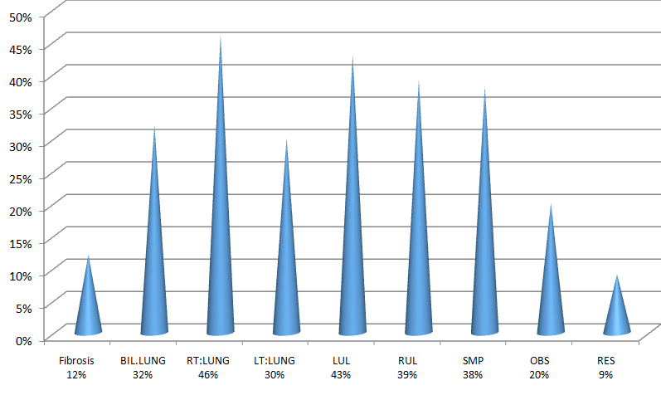
Figure No.1: Lung involvement with percentage
Table No.2: Number of patients with age.
Number of patients | Age
27 | 30-40 years
63 | 40-50 years
10 | 50-60
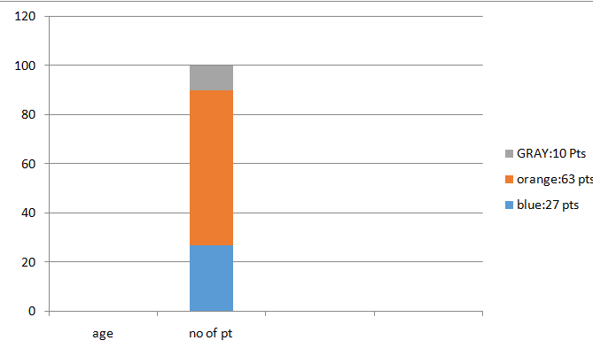
Figure No.2: Number of patients with age.
Table No.3: Ratio of smoker and non smoker among patients
No. of patients. | sex | smoker | Non smoker
17 | females | positive | Negative
18 | females | negative | Positive
40 | males | positive | Negative
25 | males | negative | Positive
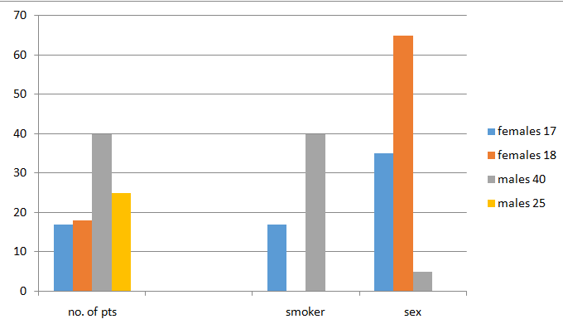
Figure No.3: Ratio of smoker and non smoker among patients
Table No.4: Marital Status
Married | 63
Un married | 9
Widow | 20
Divorce | 8
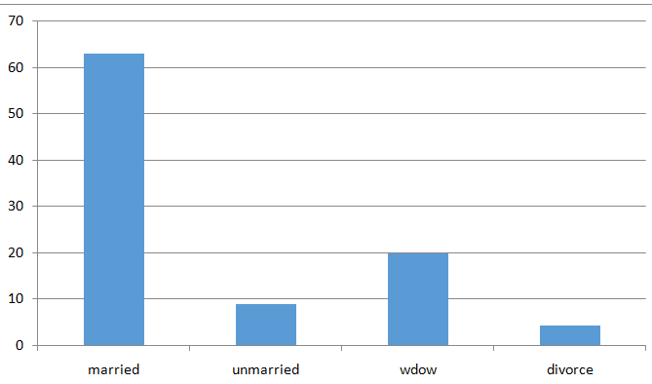
Figure No.4: Marital Status
Table No.5: Symptoms
symptoms | Percentage
Productive cough | 87%
Breathlessness | 93%
Haemoptysis | 28%
COPD | 21%
Hypertension | 22%
Type 2 Diabetes mellitus | 7%
Ischemic heart disease | 2%
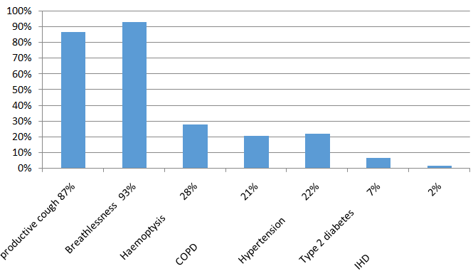
Figure No.5: Symptoms
Table No.6: Socio economical
No. of Patients | Status
20 | Lower
53 | Lower middle
22 | Middle
05 | Upper middle
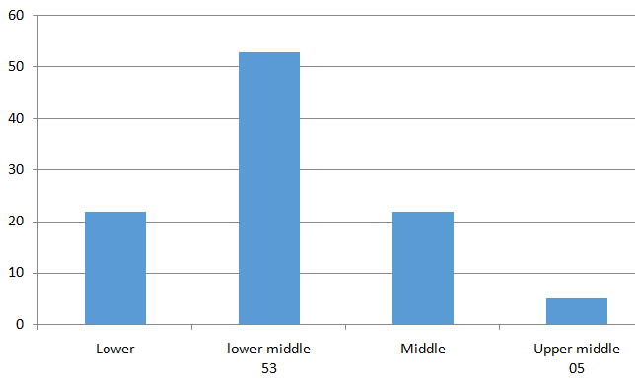
Figure No.6: Socio economical
Bilateral involvement was 32% on spirometry mixed pattern 38% cases obstructive 20 cases restrictive 9 cases. The Management maintain nutrition. Antibiotics (clarithromycin, moxifloxacin and and ceftriaxone) postural drainage.
Table No.7: Education
35 | Illiterate
20 | Primary
15 | Middle
12 | Matriculation
10 | Graduation
O8 | Masters

Figure No.7: Education
Table No.8: Occupation
Name of occupation | No. of pts.
Farmers | 40
House wife | 30
Unemployed | 10
Service | 3
Laborer | 17
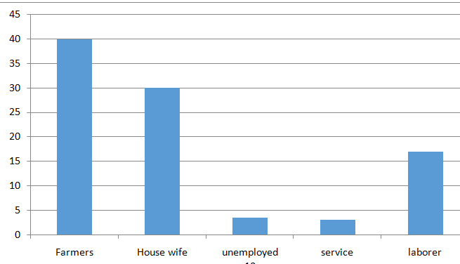
Figure No.8: Occupation
DISCUSSION
Bronchiectasis is defined as the permanent dilatation and distortion of airways. Toni jordan et al indicated that the incidence of post TB Bronchiectasis was in the range of 19%-65%. TB is the most common identified cause.²⁸
Bronchiectasis can be considered as orphan lung disease. It is common in extensive pulmonary TB since
the time of osler.²⁹ In TB endemic countries it is observed that Bronchiectasis disease is high as 85% in TB treated patients.^{30,31} For this reason non invasive test(CT Scan) is recommended.³² In Nepal patients presented with Bronchiectasis most commonly in post TB treated patients. TB is granulomatous disease, complication can be develop even successful treatment or and off treatment occupational lung disease can play role in the development of Bronchiectasis, like coal workers mill workers farmers.
We can define Bronchiectasis as irreversible dilation of bronchi, destruction of elastic and muscular elements of bronchial walls. Secondary infection occurs commonly by staphylococci, klebsella, haemophilus influenza and pseudomonas in Bronchiectasis³³
In Bronchiectasis there is granulomatous inflammation, caseation necrosis, scarring, peribronchial stenosis pooling of secretion.
Bronchiectasis was seen commonly in upper lobes (48%) in prospective study. According Brock et al upper lobes involvement was seen in 22% cases.³⁴ Middle lobe involvement was seen in 64% cases in their studies.
Smoking is aggravating factor in Bronchiectasis.
Major complications were noted pneumothorax and corpulmonale.
Similar complication were reported by Jones et al in active post TB Bronchiectasis³⁵
According to Rajasekharan, et al pulmonary kocks was the main cause for destruction of lung in their studies.³⁶
According to previous studies, Fungal colonization was noted in many cases.³⁷
Bronchoscopy is useful in resistant cases to antibiotic treatment and postural drainage³⁸.
CONCLUSION
There are so many complications of untreated pulmonary TB,
Post TB Bronchiectasis is treatable disease mild Bronchiectasis with infections is treated with antiotic treatment and postural drainage. Complete treatment by DOTS in TB prevents complications and complete cure of disease. Fibre optic bronchoscopy and sputum examination are important to rule out disease severity in those patients where drug resistant is problem. Complication are increased with concomitant COPD. Only few cases needed anti TB treatment and rarely surgery. Maintenance of nutrition is necessary malnutrition was the main problem noted in this study. Proper education about disease diet and treatment is compulsory.
Conflict of Interest: The study has no conflict of interest to declare by any author.
REFERENCES
- WHO, Global Tuberculosis 2015.
- World Health Orgnization Global Tuberculosis 2014 available on line at, http://www. who.int/tb/publications/global report/en/
- Zumla A, Raviglione M, Hafner R, Fordham von Reyn C. Tuberculosis N, Engl J Med 2013;368: 745-755.
- Van Zyl Smit RN, Pai M, Yew WW, Leung C C, et al, Global lung health, colliding epidemics of Tuberculosis, tobacco smoking, HIV and COPD. Eur Resp J 2010;35:27-33.
- Hnizdo E, Singh T, Churchyard D. Chronic pulmonary function impairment caused by initial and recurrent pulmonary Tuberculosis following treatment Thorax 2000;55:32-38.
- Laennec RT. A treatise on the disease[s] of the chest. New York: published under the auspices of the library of the New York academy of medicine by Hafner pub.co(1962)
- What is Bronchiectasis? NHLBL. June 2, 2014. Retrieved 10 august 2016.
- How Bronchiectasis Treated? NHLBL. June 2, 2014. Retrieved 10 August 2016.
- Barker AF, Bronchiectasis N. Engl J Med 2002; 346(18):1383-93.
- Flume PA, Yankaskas JR, Ebling M, Hulsey T, Clark LL. Massive haemptysis in cystic fibrosis, Chest 2005;128(2):729-38.
- Colladge NR, Walker BR, Ralston SH, editors. Davidson’s principles and practice of medicine. Illustrated by Robert Britton, 21sted. Edinburgh: Churchill Livingstone/Elsevier; 2010. ISBN 978-0-7020-3085-7.
- Hill Adam T, Mark P, Charles C, Sally W, Diana B. Primary care summary of the British Thoracic society Guideline on the management of Non cystic Fibrosis Bronchiectasis. Primary Care Respiratory J 2011;20(2):135-40.
- Dupont M, Gacouin A, Lena H, et al. Survival of patients with Bronchiectasis after thr first ICU stay for respiratory failure. Chest 2004;125(5):1815-20.
- Evans DJ, Bara AL, Greenstone M. Prolonged antibiotics for purulent Bronchiectasis in children and adults. Cochrane Database Syst Rev 2007 ;(2): CD001392.
- Davies G, Wilson R. Prophylatic antibiotic treatment of Bronchiectasis with Azithromycin. Thorax 2004;59(6):540-1.
- Tagya E, Tamaoki J, Kondo M, Nagai A, Effect of short course of clarithromycin therapy on sputum production in patients with chronic airway hypersecretion. Chest 2002;122(1):213-8.
- Yalcin E, Kiper N, Ozcelic U, Dogru D, Firat P, Sahin A, Effects of clarithromycin on inflammatory parameters and clinical condition in children with Bronchiectasis. J Clin Pharm Ther 2006;31(1): 49-55.
- Evans DJ, Bara AL, Greenstone M, Prolonged antibiotics for purulent Bronchiectasis. Cochrane database. Syst Rev 2003;(4):CD 001392.
- Evans DJ, Greenstone M. Long term antibiotics in the management of non-CF Bronchiectasis do they improve outcome? Respir Med 2003;97(7): 851-8.
- Barker AF, Couch L, Fiel SB, et al. Tobramycin solution for inhalation reduces sputum Pseudommonas aeuroginosa density in Bronchiectasis. Am J Respir Crit Care Med 2002; 162(2pt1): 481-5.
- Schenberg P, Shore E, A pilot study of the safety and efficacy of tobramycin solution for inhalation patients with severe Bronchiectasis. Chest 2005; 127(4): 1420-6.
- Lin H, Cheng H, Wang C, et al. Inhaled gentamycin reduces airway neutrophil activity and mucus secretion in Bronchiectasis. Am J Respir Crit Care Med1999;155:2024-29.
- Steinfort DP, Steinfort C, Effect of long term nebulized colistin on lung function and quality of life in patients with chronic bronchial sepsis. Int J Med 2007;37(7): 495-8.
- Otgun I, Karnak I, Tanyel FC, Senocak ME, Buyukpamukcu N. Surgical treatment of Bronchiectasis in children and adults. J Pediatr Surg 2004;39(10):1532-6.
- Elborn JS, Johnston B, Allen F, Clarke J, McGrarry J, Varghese G. Inhaled steroids in patients with Bronchiectasis. Respire Med 1992;86 (2):121-4.
- Patterson JE, Hewitt O, Kent L, Bradburry I, Elborn JS, Bradley JM, Acapella versus usual air way clearance during acute exacerbation in Bronchiectasis a randomized crossover trial. Chron Respir Dis 2007;4(2):67-74.
- Eaton T, Young P, Zeng I, Kolbe J, A randomized evaluation of the acute efficacy, acceptiblity and tolerability of flutter and active cycle of breathing with and without postural drainage innon cystic fibrosis Bronchiectasis. Chron Respir Dis 2007; 4(1):23-30.
- Jordan Toni S, Spencer Elspeth M, Davies Peter. Tuberculosis, Bronchiectasis and chronic air flow obstruction. Respiratory 2010;15:623-8.
- Care T, Osler S. Principles and Practice of Medicine. 10th ed, D, Appleton and Co: New York;1926.p.628. New61 Grancher JJ. La dilatation des bronchus ches les tuberculeux Gazz Med de paris 1878;146.
- Salkin, D, Tuberculosis as a cause of upper lobe Bronchiectasis. Cal Med1950;73:577-580. New63, Hansell DM. Bonchiectasis. Radiol Clin North Am 1998;36:107-128.
- Lee ES, Park CM, Goo LM, Yim JJ, et al, Computerized tomography of extensively drug resistant pulmonary tuberculosis in non HIV infected patients J of comp Asis Tom 2010;34: 559-563.
- Yeom, JA, Jeon; D; Kim K; et al, imajing findings of primary multi drug resistant tuberculosis, a comparison with findings of drug sensitive tuberculosis, J, of Comp Asis Tom 2009;33:
956-960.
- Angrill J, Augustin C, de Cellis R, et al. bacterial colonizationin patients with Bronchiectasis: microbial pattern and risk factors. Thorax 2002;57: 15-9.
- Brock RC. Post tuberculous bronchostenosis and Bronchiectasis of the middle lobe. Thorax 1950;
5: 5.
- Jones Em, Peck WM, Woodruff CE, Willis HS. Relationships between tuberculosis and Bronchiectasis. Am Rev Tbc 1950;61: 387.
- Rajasekharan S, vallinayagi V, Jeyaganesh D. Unilateral lung destruction: acomputed tomographic evaluation. Ind J Tub 1999;183.
- Panda BN, Roska D, Verma M. pulmonary tuberculosis: A predisposing factor for colonizing and invasive aspergillosis of lungs. Ind J Tub 1998; 45: 221.
- Chandra TJ, Dash S, srinivas G, Rao PVP. A study on rapid confirmation of pulmonary tuberculosis in smear-negative acid fast bacilli cases by using fiberoptic bronchoscopy, done through a trans oro pharyngeal spacer. J Family Comm Med 2012; 19(1):43-6.

