Original Article
Epidemiologic Study and Role of MRI in Piriformis Syndrome Observed in Pakistani Population
Piriformis Syndrome
Mian Azhar Ahmad¹, Ibrahim Khalil², Safdar Hussain Arain³
ABSTRACT
Objective: To investigate role of MRI in piriformis syndrome as a possible cause of lumbago and sciatica in Pakistani population.
Study Design: Cross sectional study
Place and Duration of Study: This study was conducted at Department of Neurosurgery, Lahore General Hospital Lahore, DHQ Hospital Sahiwal and Department of Neurosurgery Unit-1, Bolan Medical College Quetta from 1st July 2013 to 31st December 2015.
Materials and Methods: This study was conducted on 2000 cases who presented with moderate to severe low backach. Out of them eighteen patients of piriformis syndrome were selected after relevant general physical examination, neurological examination and investigations. Amongst them, thirteen were women, and five men, average age thirty six years. Planned surgery was performed in three cases, during follow up of one to two years following start of clinical presentation of patients. Rest of fifteen patients received corticosteroids injections in their piriformis. Magnetic Resonance Imaging was done in all individuals patients.
Results: Three cases executed successful outcomes with medical management. Out of three patients in which surgery was performed, two patients gave favourable clinical presentation, only single patient continued complaining of discomfort. 3 additional findings were demonstrated presenting as unusual pressure on sciatic nerve due to piriformis muscles. We obtained these results after keeping patients under observations for one to two years. The highest incidence of Piriformis syndrome was seen predominantly in females.
Conclusion: The important possible reason of lumbago and sciatica is positional variations of sciatic nerve with piriformis muscle. Low backach should be investigated in association with other environmental factors to look into causes of piriformis syndrome.
Key Words: Incidence, Therapy; Sciatica; MRI; Piriformis syndromee
Citation of article: Ahmad MA, Khalil I, Arain SH. Epidemiologic Study and Role of MRI in Piriformis Syndrome Observed in Pakistani Population. Med Forum 2017;28(1):83-87.

INTRODUCTION
Piriformis syndrome is a cause of lower back pain and sciatica secondary to sciatic nerve entrapment at the greater sciatic notch.¹ It is usually caused by an abnormal condition of the piriformis muscle such as hypertrophy, inflammation, or anatomic variations.² Piriformis syndrome may be possible cause of intractable sciatica is frequently misdiagnosed or the correct diagnosis is delayed because of its rarity, nonspecific clinical symptoms, and absence of definite diagnostic tests.

^{1.} Department of Anatomy Sahiwal Medical College Sahiwal.
^{2.} Department of Neurosurgery Unit-1, Bolan Medical College Quetta.
^{3.} Department of Neurosurgery, Gambat Institute of Medical Sciences Gambat.

Correspondence: Dr. Mian Azhar Ahmad, Associate Professor of Anatomy, Sahiwal Medical College, Sahiwal.
Contact No: 03334339884
Email: drazharahmad@hotmail.com

Received: November 15, 2016; Accepted: December 29, 2016

Yeoman² stated the reason of low backach as sacroiliac joint infection, in association with anatomical morphological variations in tomography of piriformis muscle. He gave special considerations to course, relations and branches of the sciatic nerve in this regards. Literature review discloses Freiberg and Vinke³ presenting view about sacroiliac arthritis n first triggers discomforts to piriformis muscle on instance later deep connective tissue covering of piriformis muscle is involved. This series of events further cause pressure on lumbosacral nerve plexus located on piriformis fascia to bring about irritation of this nerve plexus. Indexed literature depicts Beaton and Anson⁴ putting forwards results of their work in dissection hall teachings. They postulated that sudden contraction of piriformis muscle may be most likely cause of irritation of lumbosacral plexus. The headline piriformis syndrome was suggested by Robinson.⁵ He advocated specifically an injury of piriformis muscle as underlying reason of low backach. The electro-diagnostic test precisely diagnose piriformis impingement.⁶⁻⁷ Clinical testing of lumbosacral plexus particularly peroneal nerve examination as H-reflex clearly shows relevant signs and symptoms. We suggest more strong emphysis on general physical examination and relevant neurologic testing as MRI, CT scans and other radiologic techniques inflict heavy financial burden to patients. More over these investigations are required again and again. Importantly authority full objective test to investigate piriformis muscle syndrome are not yet available. So a lot of time wastage is there looking for cause of very severe backach. Piriformis syndrome secondary to an anomalous sacral attachment of an otherwise normal piriformis muscle has been reported that was revealed on MRI and confirmed at surgical repair.⁸ Familiarity with this syndrome and its imaging findings is important for making the correct diagnosis.
MATERIALS AND METHODS
This descriptive cross sectional hospital based study was carried out in Department of Neurosurgery, Lahore General Hospital Lahore, DHQ Hospital Sahiwal and Department of Neurosurgery, Bolan Medical College Quetta. This research work was conducted on 2000 cases who presented with lumbago sciatica, aches and pains on back, were thoroughly investigated, with age range between 16-78 years. They were admitted through out patient departments of recommended hospitals from 1st July 2013 to 31st December 2015. Patient’s age was between 18-70 years, with female dominance. Eighteen patients of piriformis syndrome were selected, fifteen were females and three males, ten patients had a pain left while eight on right side. Operative work was done in six cases in which medical treatment was not successful or those patients had diseases related to muscles or nerves. Amongst fifteen patients who were managed medically, ten were females and five males, ten patients had pains mainly on left side while in five on right side. Not a single patient gave any past history of injury to the back. Three patients were basically sportsmen, a single patient was a professional cricketer, second patient was a national level hockey player, third patient was soccer payer in a club. Many patients had complaint of pain but did not take any medications few patients did start taking drugs. Mean time period between start of symptoms and initiation of therapy was calculated to be from two months to four years, single patient gave history of unsuccessful operation on lumbar spine for low backach. In 5 patients we gave intramuscular corticosteroids injections in their piriformis which produced excellent results and patients were symptoms free. In three patients in which surgery was done, two were females and one was male, two patients had complaints more on left side and one on right side. Seventy two kilogram was the average weight of he patients. Detailed scrutiny of 3 sportsmen in current study group, showed that, only one patient had a previous history of a fall onto a buttock, 3 months before the onset of the symptoms. All patients had followed a preoperative medical treatment including painkillers and muscle relaxants; three have also had intrapiriformis muscle steroids injection. The time average from the beginning of the pain to surgery was: range, 1 to 3 years. The preoperative and last followup evaluation concerning the clinical status and the results of the MRI images and the H-reflex of the peroneal nerve. In one patient complete nervous system testing before surgery demonstrated foot drop on right side, In another case we found that patient was assisted to stand up in a triple flexion position while he was directed to stand for a longer deuration. In four cases we demonstrated variable sensations in association with changing reflexes. Wasting of muscles in gluteal region was demonstrated in yet another individual and in another patient, had wasting of muscles in back leg muscles. Magnetic resonance imaging was done in all the patients and no patient was found to have lesions like nerve root compression or any other disease involving vertebral column which could trigger low backpack in these patients. A pelvic Magnetic resonance imaging was done in all study group individuals clear cut increase in size of piriformis muscle was found in five patients, three patients we found little engorged veins in the vicinity of sciatic nerve. Variability of “H reflex of the tibial nerve was demonstrated in three patients. In 7 cases, we decided to investigate H reflex of the common peroneal nerve.
RESULTS
These are results of study on 2000 patients, amongst whom 18 patients of piriformis syndrome were selected. 15 patients were conservatively managed. Follow up of patients continued for period ranging from one year to four years. Conservatively managed single patient showed successful clinical out comes. Two cases gave excellent results with intra muscular injections in piriformis muscle. Medical treatment was not helpful in 5 cases. One case did not report and was declared as left against medical advised. Excellent clinical outcomes were achieved in three patients in which surgery was done. We kept following them till four years and these cases remained totally symptoms free. Proper favorable results were received in 4 cases even long duration of sitting episodes, they did not complain of any kind of pain. Mild to moderate low back ach was documented in 3 cases after really exertional exercises. One woman patient looked dissatisfied with surgery. Somehow we did not investigate and did any neurological testing on to her. Sensory deficit was noted in 3 cases prior to surgery. Tinnel sign was observed in these patients till six months. In one individual sensory and motor deficit was found in the vicinity and area of distribution of deep peroneal nerve. Complete physical recovery was observed in that patient with a drop foot within duration seven months. No walking aids were not needed by any patient after surgery. Transitory limp and one superficial cutaneous infection after operation were found in one patient.
Neurosurgical steps included Kocher-Langenbeck incision in a prone position, the piriformis muscle was approached via the fibers of the gluteus maximum and was cut after the safety of nerve was ensured. Whole of surgical technique did pivot around sciatic nerve in all the patients. Bifid sciatic nerve was documented coursing behind hypertrophied piriformis muscle. It was observed. A bifid piriformis muscle and a bifid sciatic nerve, particularly a single branch of the nerve was found coursing proximal to the muscle and the other one through the split (Fig. 1).

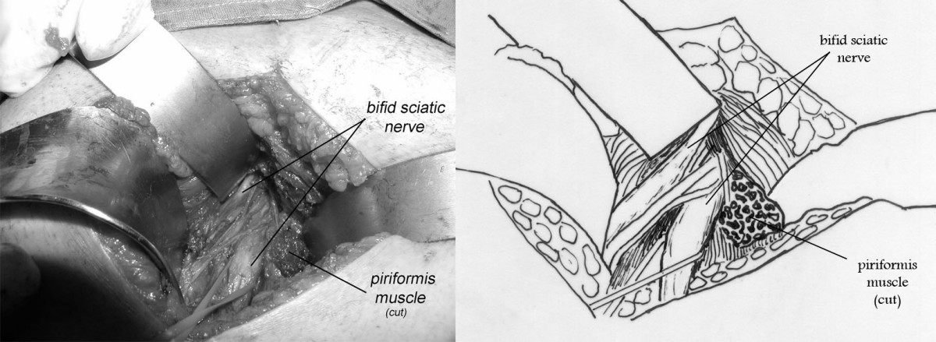
Figure No. 1: Bifid piriformis muscle and bifid sciatic nerve

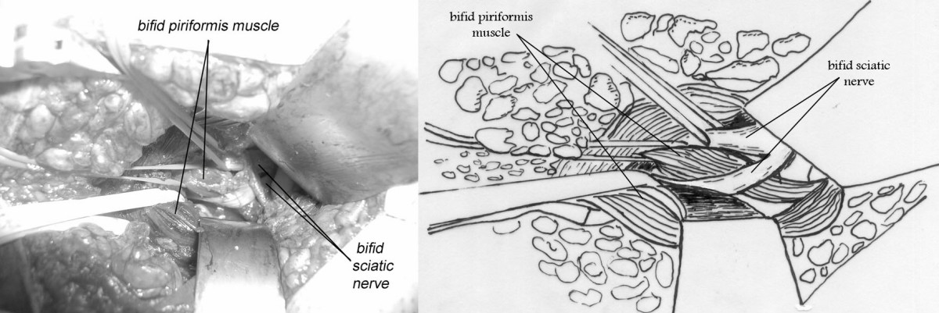
Figure No.2: Sciatic nerve entrapment by piriformis muscle and the sacrosciatic ligament

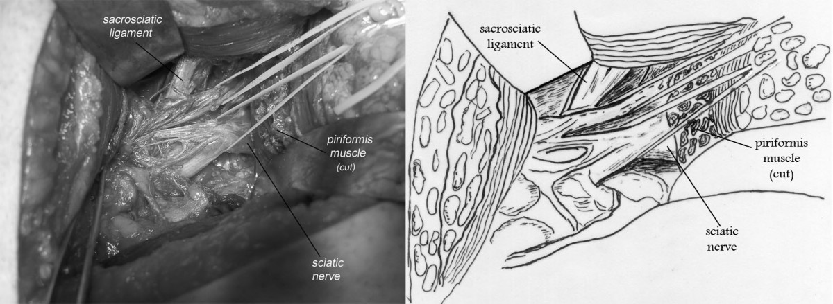
Figure No.. 3: Piriformis muscle syndrome on right side
The piriformis muscle was hypertrophied, squeezing the sciatic nerve which passed directly below it, 2 cases. A transverse fibrous band compressed the sciatic nerve, 1 case (Fig. 2).In one case. A sciatic nerve and the inferior gluteal nerve were found to have interconnected by enormous tissue, 1 patient, sciatic nerve compression was not noted in any of the patients in which surgery was done in three cases. Engorded varicosed venous channels were demonstrated in the vicinity of sciatic nerve in all study group cases.
This woman presented with piriformis muscle syndrome on right side of four years duration. We noted intraoperatively a bifid sciatic nerve was found during operation coursing under more than normal size piriformis muscle (Fig. 3).
DISCUSSION
Sciatic nerve impingement at the buttock,precipitating the piriformis syndrome, can present as low back pain could have. MRI being principal investigation to investigate spinal disease. The etiology of piriformis muscle syndrome is is unknown, diversified symptom complex is a feature of this disorder even characteristic physical signs on neurologic examination are not specific. Adequate diagnosis of this syndrome at primary health and secondary health care level is rare except high index of suspicion, and patients then are referred to specialist centers, reported cases were sporadic having unusual incidence, from 0.33%⁸ to 6%⁹ but this is related as to which point patients are referred to specialist neurological centers. However, once medical management is not successful, 5% patients were received in higher centers, Adams¹⁰ and Robinson.⁵ Beauchesne et al¹¹ recorded high objection to that aggravated rate and proposed patients sent to specialist neurological centers must not be greater than 1%. Importantly this in agreement to results of our research work documented as 0.7%, further we did not receive any referred patients. This stated that it is yet not confirmed whether exact cause of Piriformis muscle syndrome is within muscle or primary cause is located in a nerve. It is recommended that clinical presentation must be combined with radiological investigations to reach at a diagnosis.
Current research work has confirmed lack of any links of sacroiliac joint syndrome with piriformis syndrome, more over we have proved that when patient is not complaining of sacroiliac pain and it is proved also on physical examination and investigations, piriformis syndrome turns to be basically a diagnosis of exclusion. An insight into literature reveals that many authors disagree with our findings but results of work by Bernard and Kirkaldy-Willis¹² coincide with our results. According to Robinson⁵ piriformis syndrome, is characterized by classical clinical presentation where low back ach, pain in vicinity of sacroiliac joint, greater sciatic notch is main feature, and because piriformis muscle inserts onto femur, its spasm cause painful movements. This pain is aggravated by bending and heavy weight lifting with a strong history of injury to back, sacroiliac and gluteal area. On physical and neurological examination, a tender mass palpable, on piriformis muscle on damaged side, Lasègue sign can be elicited. Wasting of muscles in gluteal region extent of which is linked with time period. Indexed literature strongly advocates positive past history of injury as principal reason of piriformis syndrome which is contrary to our findings where only one patient gave history of injury.^{4-6,12} Exaggerated rotators muscles over work in patients strenuous exercises, sportsmen, hockey players, sprinters, professional soccer players where sciatic nerve is most likely to be injured in patients who sit for longer periods. Our results are similar to work done by Freiberg and Vinke³, in those series of patients pain was triggered by passive internal rotation and hip adduction. Our results were in contradiction to work by Pace¹³ pain was triggered by resisted abduction and external rotation of damaged thigh as a salient feature of syndrome. Magnetic resonance imaging plays an important role in diagnosing Piriformis syndrome, Pecina et al¹⁴ has documented piriformis derrangment seven out of ten patients. This is stated that magnetic resonance imaging main investigation for piriformis syndrome, more so in cases who have long standing sciatica. However, and apart from, we did not apply magnetic resonance neurography and piriformis blocks,^{15,16} pelvic magnetic resonance imaging remained chief investigation with current research work, more over topography of Piriformis muscle is variable as documented in our study, and is frequently found in heathy population. Pelvic T1-weighted magnetic resonance imaging is relevant investigation and was done in one hundred patients.¹⁷ Nerve conduction and electromyographic are another means to reach at is diagnosis, can be considered but these are not easy tests to be performed, and their contribution to diagnosis is not yet established, though these taste have been mentioned in literature. However, it is well admitted that the tibial component of sciatic nerve division of the nerve in piriformis syndrome is normally unaffected⁶ while inferior gluteal nerve which innervates gluteus maximum can be involved leading to wastage of piriformis muscle mass and reduction of muscle size which has been documented in current research work also. Fishman et al¹⁷ has stated that sciatic nerve entrapment weakens H-reflex bur many researchers do not agree with this observation^{5,6} as they receive diversified outcomes regarding tibial nerve. We believe H reflex of the peroneal nerve is more authorityful as compared to tibial nerve. Morphological and topographic research work regarding piriformis muscle conducted in past doe not prove any links between physical findings and structure of and variable shapes and size of piriformis syndrome. Reseach work on cadaver dissections of two hundreds and forty has documented that in 90% of cases sciatic nerve exits at lower border of piriformis muscle, in 7%, piriformis and sciatic nerve appear split, single ramification of sciatic nerve courses via split while second travels distal to the muscle, and in 2% cases sciatic nerve was found to be split, in 1% piriformis was documented to be split by sciatic nerve.³ Tofighi¹⁸ proposed that in 6.15% of cases, peroneal nerve courses through piriformis tendon and suggested a strong association between this anomaly and initiation and progression of piriformis syndrome. Literature review reveals the cadaveric^{3,19} and surgical illustrations^{5,19-21}, three findings already stated (Fig. 1-3). So we hypothesize that morphological, anatomical and topographical variations of piriformis and sciatic nerve are of paramount significance in causation of piriformis syndrome as compared to just relation between sciatic nerve and piriformis muscle. This is recommended that proper emphysis must be given environmental factors like routine exercise, athletic activity of the individual which contribute to clinical presentation of piriformis syndrome.
CONCLUSION
Current research work has presented topographical variants of piriformis syndrome and also documented characteristic clinical presentation with radiological features which may be of utmost practical importance to prevent diagnostic errors and uncertainties regarding many spinal diseases. Environmental factors with anatomical variations must be considered to illustrate real etiology of low back ach. Our recommendations are of significance to meet advanced trends regarding recent treatment of piriformis syndrome.
Conflict of Interest: The study has no conflict of interest to declare by any author.
REFERENCES
- Standing S, Ellis H, Healy JC, Johnson D, Williams A, Collins P. Gray's anatomy. 39th ed. New York: Churchill Livingstone;2005.p.1189–90.
- Yeoman W. The relation of arthritis of the sacroiliac joint to sciatica: with an analysis of 100 cases. Lancet 1928;2:1119–22.
- Freiburg AH, Vinke TA: Sciatica and the sacro-iliac joint. J Bone Joint Surg 1934;16:126
- Beaton LE, Anson BJ. The relation of sciatic nerve and its sub divisions to the piriformis muscle. Anat Rec 1937;70:1–5.
- Robinson DR. Piriformis syndrome in relation to sciatic pain. Am J Surg V 1947;LXXIII, 355-8
- Paul UK, Naushaba H, Alam MJ, Begum T, Rahman A, Akhter J. Length of vermiform appendix: a postmortem study. Bangladesh J Anatomy 2011;9(1):10–12.
- Papadopoulos SM, McGillicuddy JE, Albers JW. Unusual cause of `piriformis muscle syndrome. Arch Neurol 1990; 47:1144 –6.
- Uchio Y, Nishikawa U, Ochi M, et al. Bilateral piriformis syndrome after total hip arthroplasty. Arch Orthop Trauma Surg 1998; 117:177-9.
- Pittman-Waller VA, Myers JG, Stewart RM, et al. Appendicitis: why so complicated? Analysis of 5755 consecutive appendectomies. Am Surg 2000; 66(6): 548–54.
- Adams JA. The pyriformis syndrome - report of four cases and review of the literature. S Afr J Surg 1980;18:13–18.
- Beauchesne RP, Schutzer SF. Myositis ossificans of the piriformis muscle: an unusual cause of piriformis syndrome: a case report. J Bone Joint Surg 1997;79:906–910.
- Bernard TN, Kirkaldy-Willis WH. Recognizing specific characteristics of nonspecific low back pain. Clin Orthop 1987;217:266–280.
- Pace JB: The psychophysiology of pain: Diagnostic and therapeutic implications. J Fam Practice 1975;1:9-13.
- Pecina HI, Boric I, Smoljanovic T, Duvancic D, Pecina M. Surgical evaluation of magnetic resonance imaging findings in piriformis muscle syndrome. Skelet Radiol 2008;37:1019–1023
- Ahangar S, Zaz M, Shah M, Wani SN. Perforated subhepatic appendix presenting as gas under diaphragm. Indian J Surg 2010;72(3): 273–4.
- Nayak SB, George BM, Mishra S, Surendran S, Shetty P, Shetty SD. Sessile ileum, subhepatic cecum, and uncinate appendix that might lead to a diagnostic dilemma. Anatomy Cell Biol 2013; 46(4): 296–8.
- Fishman LM, Schaefer MP. Piriforms syndrome: the piriformis syndrome is underdiagnosed. Muscle Nerve 2003;28:646–649.
- Tofighi H, Taghadosi-Nejad F, Abbaspour A, et al. The anatomical position of appendix in Iranian cadavers. Int J Med Toxicol Forensic Med 2013; 3(4): 126–30.
- Setty SNRS, Katikireddi RS. Morphometric study of human cadaveric caecum and vermiform appendix. Int J Health Sci Res 2013; 3(10): 48–55.
- Willmore WS, Hill AG. Acute appendicitis in a Kenyan rural hospital. East Afr Med J 2001; 78(7): 355–7.
- Iqbal T, Amanullah A, Nawaz R. Pattern and positions of vermiform appendix in people of Bannu district. Gomal J Med Sci 2012;10(2):
100–3.

