Original Article
Serum Ferritin in Helicobacter Pylori Infected Young Adult Female
Ferritin in Helicobacter Pylori
Inayatullah Memon
ABSTRACT
Objective: To determine serum iron (Fe++), serum ferritin and total iron binding capacity (TIBC) in Helicobacter pylori (H. pylori) infected young adult female.
Study Design: Case control study
Place and Duration of Study: This study was conducted at the Department of Pathology, Indus Medical College Tando Muhammad Khan from September 2015- August 2016.
Materials and Methods: A sample of 50 healthy controls and 50 H pylori positive female was studied. 5 ml of venous blood was collected after aseptic measures from ante cubital vein. 2 ml was shifted to EDTA mixed tubes for blood cell counts, and 3 ml was centrifuged at 3000 x rpm for ten minutes. Sera were separated to estimate serum iron profile. Helicobacter pylori stool specific antigen (HpSA) was detected by Elisa assay kit (Fortess). SPSS 22.0 (USA) was used for data analysis at 95% CI (P≤ 0.05).
Results: The hemoglobin (Hb), hematocrit (Hct), RBC counts, serum Fe++, and serum ferritin were decreased with raised TIBC in H.pylori infected female (P<0.05). Serum ferritin in controls and cases (H.pylori +ve) was noted as 140.8 ± 20.09 and 126.5 ± 35.02 ng/dl respectively (P=0.014).
Conclusion: The present study reports low serum iron, low serum ferritin and low hemoglobin and raised total iron binding capacity in Helicobacter pylori infected young adult female.
Key Words: Helicobacter pylori, Serum iron, Serum ferritin, Young female
Citation of article: Memon I. Serum Ferritin in Helicobacter Pylori Infected Young Adult Female. Med Forum 2017;28(1):69-72.

INTRODUCTION
Helicobacter pylori (H. pylori) are microaerophilic, Gram-negative bacteria. H. pylori infect >50% of the World population and has proved a notorious pathogen. H. pylori are capable of survival in acid pH of stomach.¹ Mode of transmission of H.pylori is by oral route. Transmission occurs with families and community.² Over 80% of H.pylori infected subjects are asymptomatic and remaining complains of symptoms suggestive of acute and chronic gastritis, pangastritis, peptic ulceration and risk of developing gastric cancer.³ H. pylori survive in the acidic environment by ammonia production by Urease enzyme.⁴ H.pylori colonizes the mucosa cells and resides in superficial layers but may invade and enter into mucosal epithelial cells.⁵ H.pylori persists for long durations and elicits host immune responses.⁶ H.pylori induces autoimmune phenomena against the parietal cells of the stomach thus impair the hydrochloric acid secreting capacity.

^{1.} Department of Pathology, Indus Medical Colleges, T.M. Khan, Sindh.

Correspondence: Dr. Inayatullah Memon, Assistant Professor of Pathology, Indus Medical Colleges, T. M. Khan, Sindh
Contact No: 0300-9371766
Email: memon.inayat@gmail.com

Received: November 15, 2016; Accepted: December 23, 2016

Lack of acid impairs the digestion of food in the stomach. Iron needs presence of acid for becoming soluble from ferric to ferrous form which is absorbed easily, thus its absorption is impaired resulting in iron deficiency.⁷ Previous studies suggest link of H.pylori and iron deficiency anemia with low serum ferritin levels.⁸ Eradication of H. pylori was reported to improve the total blood iron profile in children and adults.⁹ Mechanism of how H.pylori causes iron deficiency anemia is not well established.¹⁰ One suggested mechanisms is alteration of intra-gastric pH which impairs iron absorption. Other possibilities include defects in the expression of iron transporters, and iron consumption by H. pylori itself.¹¹ Another previous study reported the H.pylori interferes with iron chelation from lactoferrin. H.pylori expresses lactoferrin binding protein which helps in iron chelation resulting in iron deficiency anemia.¹² Ferritin is iron binding storage and transport protein. H.pylori takes up iron form circulating ferritin necessary for bacterial growth.¹³ As the H.pylori is prevalent in the country, it needs more studies on the iron deficiency anemia and its effect on serum ferritin levels. In this context, the present study was conducted to determine serum Fe++, total iron binding capacity (TIBC) and serum ferritin levels in H.pylori infected young adult female reporting at our tertiary care hospital presenting with the symptoms of dyspepsia.

MATERIALS AND METHODS
The study was carried out in the Department of Pathology, subjects of present case control study were selected from the indoor patients admitted in the medical wards of Indus Medical College Tando Muhammad Khan, from September 2015- August 2016. Prior permission was taken from the ethical review committee of the institute. Fifty controls and fifty cases (H.pylori positive) were selected for study. Study subjects were age matched, selected through non-probability (purposive) sampling. Inclusion and exclusion criteria were exercised. Adult female complaining of Epigastric complaints and dyspepsia and H.pylori positive of young age was the inclusion criteria. All volunteers were examined by female medical officer followed by a consultant physician. Volunteers were asked for blood sampling. 5 ml of venous blood was collected after aseptic measures from ante cubital vein. 2 ml was shifted to EDTA mixed tubes for hemoglobin, hematocrit and blood cell counts, and 3 ml was centrifuged at 3000 x rpm for ten minutes. Sera were separated to estimate serum ferritin, serum iron and total iron binding capacity (TIBC). Helicobacter pylori stool specific antigen (HpSA) was detected by Elisa assay kit (Fortess). Immulite immunoassay kit (Chemiluminnescent system, UK) was used for serum ferritin detection. Reference range of serum ferritin was 5- 148 ng/ml for females. A young pregnant female taking multi vitamin and multi mineral pill was strict exclusion criterion. Female suffering from major systemic diseases was excluded. Female facilitators were appointed for complying with the study protocol. Cobas e 411 analyzer (Roche Diagnosis GmbH, Mannheim, Germany) was used for biochemistry analysis. A pre-designed pre structured proforma was used for data collection. Written informed consent was mandatory for study protocol. SPSS 22.0 (USA) was used for data analysis. Independent sample Student`s t-test was used for comparison between groups for continuous variables. Confidence interval was defined significant at 95% (P≤ 0.05). Results were presented as mean ± standard deviation (SD) and graphs.
RESULTS
The present study included 100 normal healthy adult aged matched female. Table 1 shows the age distribution, hemoglobin (Hb), hematocrit (Hct), RBC counts, serum Fe++, TIBC and serum ferritin levels in controls and cases. The Hb, Hct, RBC counts, serum Fe++, TIBC and serum ferritin levels were decreased in H.pylori infected female compared to controls. Serum ferritin in controls and cases (H.pylori +ve) was noted as 140.8 ± 20.09 and 126.5 ± 35.02 ng/dl respectively (P=0.014). Box plot graph 1-3 show the serum Fe++, serum TIBC and serum ferritin levels in controls and cases (P<0.05).
Table No.1: Clinicopathological findings in study population (n=100)
 | Groups | Mean | SD | P-value
Age (years) | Controls | 35.48 | 8.83 | 0.15
Age (years) | Cases | 33.30 | 3.97 | 0.15
Hemoglobin (g/dl) | Controls | 13.15 | 2.50 | 0.039
Hemoglobin (g/dl) | Cases | 12.51 | 3.82 | 0.039
Hematocrit (Hct.) (%) | Controls | 41.92 | 5.29 | 0.048
Hematocrit (Hct.) (%) | Cases | 39.16 | 8.19 | 0.048
Red Blood Cell (106/µL) | Controls | 4.25 | 0.22 | 0.0001
Red Blood Cell (106/µL) | Cases | 3.95 | 0.53 | 0.0001
Serum Fe++ (μg/dl) | Controls | 152.72 | 6.11 | 0.0001
Serum Fe++ (μg/dl) | Cases | 116.92 | 42.39 | 0.0001
TIBC (μg/dl) | Controls | 394.34 | 137.20 | 0.0001
TIBC (μg/dl) | Cases | 521.36 | 108.95 | 0.0001
Serum Ferritin (ng/dl) | Controls | 140.80 | 20.09 | 0.014
Serum Ferritin (ng/dl) | Cases | 126.55 | 35.02 | 0.014
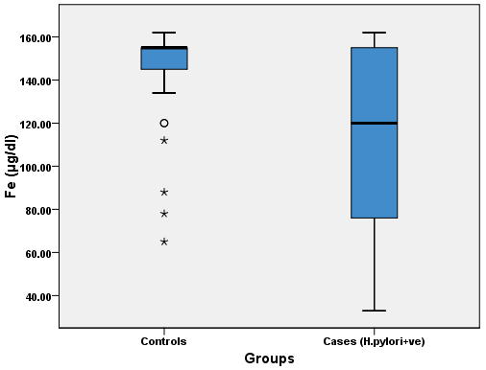
Graph No.1: Serum iron levels in controls and cases
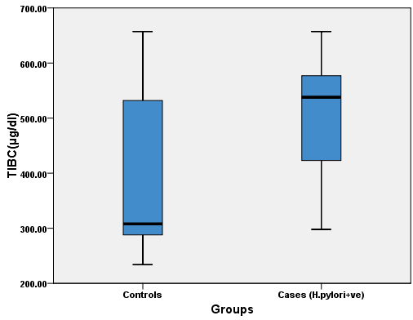
Graph No.2. Serum TIBC levels in controls and cases

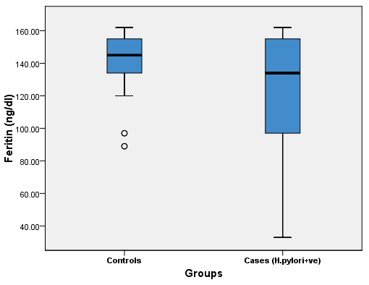
Graph No.3. Serum ferritin levels in controls and cases
DISCUSSION
The present is the first study being reported on the serum ferritin in Helicobacter pylori (H. pylori) infected young adult female from our tertiary care hospital. H. pylori are considered a risk factor of iron deficiency and low serum ferritin.¹⁴ H. pylori now infect 50% population of World and are prevalent in the Pakistan and similarly the iron deficiency is very common in developing countries.¹⁵ The present study reports low Hb, Hct, RBC counts, serum Fe++, serum TIBC and serum ferritin levels in H.pylori infected female compared to controls (P=0.014). The findings of present study are in agreement with previous studies.^{16,17} H. pylori stool specific antigen indicates the study subjects were suffering from active infection, this adds to the strength of present study. Previous studies^{18,19} from developing countries have reported iron deficiency in H. pylori infected subjects; the findings support the present study. H. pylori infection is prevalent in developing countries; the reasons include poor sanitary conditions, poverty related problems, poor contaminated nutrition and life style habits. A previous review has indicated high prevalence of H. pylori infection from different Gulf countries. Studies from various countries reported high prevalence of H. pylori infection in developing countries.²⁰ The serum ferritin is major storage protein, also circulating in the body fluids, was found low in H. pylori infected young adult female in the present study. Serum ferritin is marker of iron status of body.²¹ Concomitant inflammation is reported to affect the serum ferritin. In severe inflammatory conditions the serum ferritin, being an acute phase protein, is elevated may be >50 ng/mL.²² In present study, the serum Fe++, serum TIBC and serum ferritin levels were found decreased in H.pylori infected female, this occurs due to the disturbed gastric pH and hypochlorhydria resulting in defective iron absorption. Gastric atrophy and parietal cell damage induced by H.pylori add to the problem of iron deficiency.²³ Serum ferritin was found significantly low in H.pylori infected young adult female, which is in agreement with previous studies.^{16,17} However, a few studies^{24,25} reported no such association of low serum ferritin and H.pylori; these conflicting results are most probably due to different demographics, dietary habits, and research bias. The findings of low serum ferritin in H.pylori infected cases are in agreement with previous studies.¹⁶⁻²⁰ The findings point towards the positive association of H.pylori infectivity and iron mal absorption in the present study. The major limitations of the present research study are; a small sample size and a particular ethnic group, hence the findings cannot be generalized to other settings. Also the inflammatory markers were not analyzed, but this was because of inclusion of young adult healthy study population. The strength of present study lies in its; first- young adult healthy female, 2nd – case control design, and 3rd – the H.pylori stool specific antigen was evaluated. The H.pylori stool specific antigen is a marker of active infection. The present study concludes much information has been accumulated on the issue and H.pylori infected female should be treated with H.pylori eradication therapy by physicians and be prescribed iron supplements.
CONCLUSION
The present study reports low serum iron, low serum ferritin and low hemoglobin in Helicobacter pylori infected young adult female. Timely, therapeutic and preventive measures against H.pylori infection may prevent the iron deficiency, iron deficiency anemia and anemia related morbidities in female.
Conflict of Interest: The study has no conflict of interest to declare by any author.
REFERENCES
- Sohail S, Hamid S, Anwar I, Khawar S, Qureshi HJ. Vitamin B12, Serum Ferritin and Iron status in patients with and without H. Pylori infection. Pak J Med Health Sci J M H S 2015; 9 (2) 740-3.
- Sapmaz F, Başyiğit S, Kalkan İH, Kısa Ü, Kavak EE, Güliter S. The impact of Helicobacter pylori eradication on serum hepcidin-25 level and iron parameters in patients with iron deficiency anemia. Wien Klin Wochenschr 2016; 128(9-10):335-40.
- Anoar KA. Relationship of Helicobacter Pylori Infection and Serum Ferritin Level. Int J Med Res Prof 2016;2(2); 15-20.
- Aarabi MH, Alvani S, Ehteram H. Lipid Profile in Subjects with helicobacter pylori Infection. Iranian J Pathol 2010;5(4):199 - 203.
- Algood HMS, Cover TL. Helicobacter pylori persistence: an overview of interactions between H. pylori and host immune defenses. Clin Microbiol Reviews 2006;19(4):597–613.
- Terebiznik MR, Vazquez CL, Torbicki K. Helicobacter pylori VacA toxin promotes bacterial intracellular survival in gastric epithelial cells. Infection and Immunity 2006; 74(12): 6599–6614.
- Habib HSA, Murad HAS, Amir EM, Halawa TF. Effect of sequential versus standard Helicobacter pylori eradication therapy on the associated iron deficiency anemia in children. Ind J Pharmacol 2013; 45(5): 470–473.
- Eusebi LH, Zagari RM, Bazzoli F. Epidemiology of Helicobacter pylori infection. Helicobacter 2006;9(1):1-5.
- Zuberi BF, Afsar S, Qadeer R, Baloch I, Quraishy MS, Kumar A, Akhtar N. Hemogolbin, ferritin, vitamin B12 and halicobacter pyloriinfection: a study in patients who underwent upper GI endoscopy at civil hospital karachi. J Coll Physicians Surg Pak 2007; 17(9):546-9.
- DuBois S, Kearney DJ. Iron-deficiency anemia and Helicobacter pylori infection: a review of the evidence. Am J Gastroenterol 2005;100(2):453–9.
- Choe YH, Oh YJ, Lee NG, Imoto I, Adachi Y, Toyoda N, et al. Lactoferrin sequestration and its contribution to iron-deficiency anemia in Helicobacter pylori-infected gastric mucosa. J Gastroenterol Hepatol 2003;18(8):980–5.
- Taye B, Enquselassie F, Tsegaye A, Amberbir A, Medhin G, Fogarty A, et al. Effect of early and current Helicobacter pylori infection on the risk of anaemia in 6.5-year-old Ethiopian children. BMC Infectious Diseases 2015; 15:270.
- Cooksley C, Jenks PJ, Green A, Cockayne A, Robert PH. Logan and Kim R. Hardie. NapA protects Helicobacter pylori from oxidativestress damage, and its production is influenced by the ferric uptake regulator. J Med Microbiol 2003; 52:461-9.
- Zamani A, Shariat M, Yazdi ZO, Bahremand S, Asbagh PA, Dejakam A. Relationship between Helicobacter pylori infection and Serum Ferritin level in primary school children of Tehran-Iran. J Pak Med Assoc 2011; 61:658.
- Salih BA. Helicobacter pylori Infection in Developing Countries: The Burden for How Long. Saudi J Gastroenterol 2009;15(3):201–207.
- Rajendiran S, Zachariah B, Hamide A. Increased Protein Carbonylation and Decreased Antioxidant Status in Anemic H. Pylori Infected Patients: Effect of Treatment. Gastroenterol 2014;95(159): 110-119.
- Nakagawa H, Tamura T, Mitsuda Y, Kurata M, Goto Y, Kamiya Y, et al. Association between Helicobacter pylori infection detected by the (13) C-urea breath test and low serum ferritin levels among Japanese adults 2013;18(4):309-15.
- Mohammed MO. Correlation of Endoscopic Findings with Various Helicobacter pylori Tests among. Int J Clin Med 2014;5:1180-8.
- Alsaimary I, Sadoon M, Jassim A, Hamadi S. Clinical Findings and Prevalence of Helicobacter Pylori in Patients with Gastritis B in Al-Basrah Governorate. Oman Med J 2014;24(3):208–211.
- Thankachan P, Muthayya S, Sierksma A, Eilander A, Thomas T, Duchateau GS, et al. Helicobacter pyloriinfection does not influence the efficacy of iron and vitamin B(12) fortification in marginally nourished Indian children. Eur J Clin Nutr 2010; (10):1101-7.
- Eshraghian A. Epidemiology of Helicobacter pylori infection among the healthy population in Iran and countries of the Eastern Mediterranean Region: A systematic review of prevalence and risk factors. World J Gastroenterol 2014;20(46): 17618–17625.
- Jamieson JA, Kuhnlein HV. The paradox of anemia with high meat intake: a review of the multifactorialetiology of anemia in the Inuit of North America. Nutrition Etiol Reviews 2008;66 (5):256–271.
- Windle HJ, Kelleher D, Crabtree JE. Childhood Helicobacter pylori infection and growth impairment in developing countries: a vicious cycle? Pediatrics 2007;119: E754–759.
- Hsiang-Yao Shih, Fu-Chen Kuo, Sophie SW Wang, Yi-Chang Liu, Meng-Chieh WU, Yang-Pei, et al. Helicobacter pylori Infection and Anemia in Taiwanese Adults. Gastroenterol Res Practice 2013; 2(1):211-215.
- Perez GI, Rothenbacher D, Brenner H. Epidemiology of Helicobacter pylori infection. Helicobacter 2014;9:1S–6S.

