Original Article
Quality of Record Keeping by Dental Interns working in Dental Out-Patient Department of a Dental Hospital of Karachi
Record Keeping in Dental OPD
Shanila Faisal¹, Abdul Qadir², Aqeel Ahmed Shaikh³, Muhammad Adnan Kanpurwala², Rabia Arshad⁴ and Hina Riaz¹
ABSTRACT
Objective: The aim of this study is to assess the record keeping done by the dental interns working in the outpatient department of a teaching dental hospital of Karachi.
Study Design: Cross sectional study
Place and Duration of Study: This study was conducted at the Karachi Medical and Dental College, Karachi.February to September 2016.
Materials and Methods: was done on the dental records of patient’s history took by dental interns during their house job from the patients visiting the dental outpatient department for dental care. 300 patients dental record were examined using the modified CRABEL score to assess the quality of data.
Results: The Mean (SD) CRABEL Score was 94.62% (9.4) with minimum score of 30% and a maximum score of 100%. A total of 227 (76%) records out of 300 had a CRABEL score of 95% or above whereas 26 (8.7%) recording scored 80% or below. The most frequently missing readings were Intern signature (22.3%), department name (14.3%), supervisor signature (11.7%) and history of presenting complain (11.3%). Male interns were found to be significantly (P-value=0.02) more reluctant in missing the department name as compare to their female colleague.
Conclusion: The quality of record keeping among dental interns in a teaching dental hospital of Karachi is above average in relation to modified CRABEL score. It is important to take academic measures as per need to improve the quality of record keeping.
Key Words: Dental Record, Students, CRABEL Score
Citation of article: Faisal S, Qadir A, Shaikh AA, Kanpurwala MA, Arshad R, Riaz H. Quality of Record Keeping by Dental Interns working in Dental Out-Patient Department of a Dental Hospital of Karachi. Med Forum 2017;28(1):35-38.

INTRODUCTION
Efficient record keeping is a cornerstone to an excellent clinical practice. Medical records have proven to be essential tools for concerned people with multiple interests¹ such as for treatment and management of patients, for reviewing during audit² or for the medico-legal implications. For appropriate and organized flow of treatment, precise and accurate record keeping is highly necessary. For this reason, efforts to develop standards for record keeping in dental hospitals have been made as early as in 1922.^{3,4}

^{1.} Department of Health Management, Institute of Business Management, Karachi.
^{2.} Department of Physiology, Karachi Institute of Medical Sciences, CMH, Karachi.
^{3.} Operative Dentistry, Karachi Medical and Dental College, Karachi.
^{4.} Pharmacology, Altamash Institute of Dental Medicine, Karachi.

Correspondence: Muhammad Adnan Kanpurwala, Associate Professor, Department of Physiology, Karachi Institute of Medical Sciences, CHM, Karachi.
Contact No: 0300-2364983
Email: drmuhammadadnan@hotmail.com

Received: November 15, 2016; Accepted: December 20, 2016
Clinical records play a vital role in the process of the provision of dental care as they are essential for the diagnosis, planning and correct sequencing of treatment. For that purpose, their legibility, accuracy, comprehensiveness and contemporaneousness is very necessary.⁴The records should be precise enough to deliver a complete and comprehensive picture of the advancement of the oral disease and of the consequent treatment given to the patient. Their foremost function is communication: from physician to associate, physician to or from another healthcare personnel, and for self- communication.⁵
The dental records have numerous functions and these have been widely documented. Some of these include research-based functions, for financial, administrative and quality assurance and also medico-legal concerns.^{6, 7} There is no denying the fact that the quality of care delivered can only be assessed through the maintenance of complete and accurate records, which in turn form the foundation for the evaluation of the outcome and effectiveness of the treatment. ⁸⁻¹¹ However, where good records provide a better opportunity to evaluate the treatment procedure as compared to the poor records, they in no terms ensure or guarantee the adequacy of dental care.¹²
The relatively inadequate reports in the literature related to clinical record keeping quality indicate that standard of record keeping has remained inadequate in the past.¹³ However these inadequacies can be addressed to right from the beginning when the dentists are still under training. Making it a part of assessment of the quality of training will influence the methodology of training and supervision of the undergraduate students. There is evidence to prove that the undergraduates in the United Kingdom have proved to be better in record keeping than when the training had commenced.¹⁴
The practice of dentistry is highly influenced by the resourcefulness of the dental students during their training.^{15, 16}For this reason, the future practice behavior can be predicted by the quality of records keeping. Improving the record keeping quality and standards will thus pave a way for improved dental care services offered globally. A standard or a baseline degree of accuracy and quality thus has to be formulated to fulfill this purpose. Dental schools have a major role to play in inculcating the record keeping skills of future practitioners. If proper academic measures are carried out dental record keeping competencies can be achieved as a result.
Currently, it has been observed that there is hardly any documentation about clinical records keeping. The situation thus demands the proper assessment of current practice with the prime objective of improving the healthcare quality extended to the patients by undergraduate students and to suggest changes which may bring about improvement, if it is found to be necessary. This study was undertaken with the objective to assess the quality and comprehensiveness of dental record keeping by undergraduate dental students of Karachi.
MATERIALS AND METHODS
A cross sectional study was done on the dental records of patient’s history took by dental interns during their house job from the patients visiting the dental outpatient department for dental care.
300 patients record were examined using the modified CRABEL score.
Points for quality of record keeping were awarded in different areas including: “date of documentation, demographic data, presenting complaints, past dental history, past medical history, and drug history, examination findings (of the patient), diagnosis, treatment plan, procedure done,signatures of the student and the supervising dentist, and indication of the department where the patient was seen”. Total scores were calculated as a percentage. The statistical analysis was carried out by using SPSS 20.0.

RESULTS
A total of 300 records of patient notes taken by dental interns were examined during the study. The records were marked against the modified CRABEL score in the areas of date, demographics, history, examination, procedure etc. The mean (SD) CRABEL Score was 94.62 (9.4) with minimum score of 30% and a maximum score of 100%. A total of 227 (76%) records out of 300 had a CRABEL score of 95% or above whereas 26 (8.7%) recording scored 80% or below. (Figure:1).
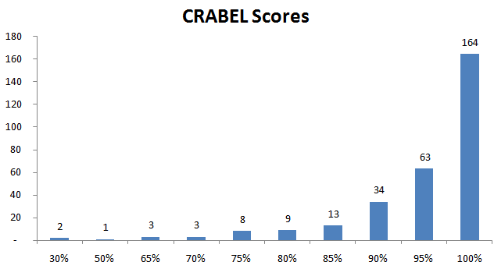
Figure No.1: Frequency of The CRABEL Scores for dental records
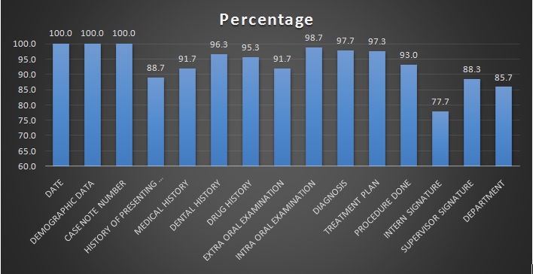
Figure No.2: Percentage of Recorded Variables as per modified CRABEL Score
The most frequently missing readings were Intern signature (22.3%), department name (14.3%), supervisor signature (11.7%) and history of presenting complain (11.3%) as shown in figure 2. The male to female comparison showed that 25 % of the males missed the signatures as compared to females which were 19 % out of 64 recordings. (Figure 3).
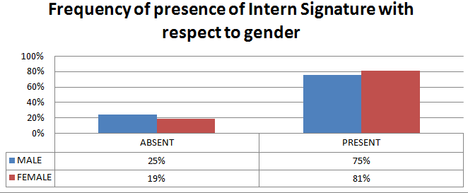
Figure No.3: Cross Tabulation between Gender and Student Signature

The second most commonly missed records was the name of department in which the patient was referred for procedure. Out of 300 records43 (14.3%) were identified which lacked the department name. The gender cross tabulation showed that 19 % of the males omitted the department name as compared to females who were 10 % of the 43 recordings. (Figure 3). This showed that male interns were found to be significantly (P-value=0.02) more reluctant in missing the department name as compare to their female colleague (mean difference with 95% C.I = 0.433; -0.84,-0.05).
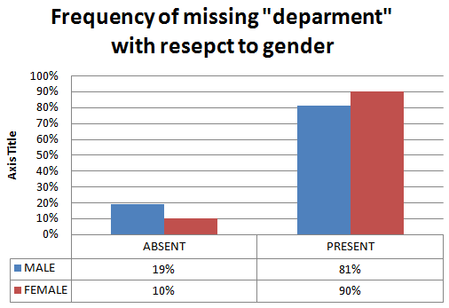
Figure No.4: Cross Tabulation between Gender and Department Name
DISCUSSION
It is an acknowledged fact that complete and accurate dental records and good patient care go hand in hand.^{17,18} Good dental records provide an opportunity to evaluate the dental care extended to the patients. They not only provide a permanent record of the treatment procedure but also aid in the making of careful diagnosis and treatment planning. Continuity of care is also made possible by the dental records as it depends upon the communication between the physicians and their teammates.¹⁹ It is a vital source of the patients’ dental condition, treatment, and medical state relevant to treatment.^{20, 21}
The results our study showed that about 76 % of the records had a CRABEL Score of 95% or above which was similar to a study conducted in Nigeria which showed that around 74 %.²² The CRABEL Score ranged between 30 to 100 % which is comparatively better to a study conducted in Britain in which the score ranged between 10 to 100 %.²³
CONCLUSION
The quality of record keeping among dental internsin a teaching dental hospital of Karachi is above average in relation to modified CRABEL score. The most frequently absent records were the intern’s signature followed by department name,supervisor’s signature and history of presenting complaint. The deficient areas highlighted by the study can be addressed by taking a few academic measures. Organizing training sessions on a regular basis that focus on the results of the study, enlighten the students about the benefits of accurate and comprehensive records and discuss the problems that might arise when records are substandard would greatly help in inculcating the trend of efficient and qualitative record keeping in the times to come.
Conflict of Interest: The study has no conflict of interest to declare by any author.
REFERENCES
- Kalra D. Medical records. Practitioner 1992;236: 533-5.
- Williams JG, Kingham MJ, Morgan JM, Davies AB. Retrospective review of hospital patient records. BMJ 1990;300:991-3.
- Archer WH. The American Dental Association and hospital dental service-a critical historical review 1920-1950. J Hosp Dent Pract 1971;5:53-58.
- Zambito RF. A history of hospital dental practice. New Dentist 1979;10:35-38.
- Faculty of General Dental Practitioners (UK). Current Guidelines for General Dental Practice. London: FGDP, January 2000.
- Medical Defence Union. Guide to good dental practice. London, Medical Defence Union Ltd, 1998.
- Charangowda BK. Dental records: an overview. J Forensic Dent Sci 2010;2(1):5-10.
- Heilminen SE, Vehkalahti M, Murtomaa H, Kekki P, Ketomäki TM. Quality evaluation of oral health record-keeping for Finnish young adults. Acta Odontol Scand 1998;56(5):288-292.
- Kapur KK, Hasse A. Planning the improvement of a hospital dental service. J Hosp Dent Pract 1979;13:89-93.
- Langdon JD, Rapidis AD. The importance of accurate records and follow-up in patients with oral cancer. J Maxillofac Surg 1978;6:226-230.
- Marcus M, Koch AL, Gershen JA. A record review model for assessing dental practices. Calif Dent J 1979;7:51-54.
- Wasserman BS. Auditing oral health care in a teaching hospital.J Hosp Dent Pract 1979;13:17-23.
- Jerge CR, Orlowski RM. Quality assurance and the dental record. Dent Clin North Am 1985;29:
483-496.
- Heilminen SE, Vehkalahti M, Murtomaa H, Kekki P, Ketomaki TM. Quality evaluation of oral health record-keeping for Finnish young adults. Acta Odontol Scand 1998;56:288-292.
- Pessian F, Beckett HA. Record keeping by undergraduate dental students: a clinical audit. Br Dent J 2004;197(11):703-705.
- Albino JE, Young SK, Neumann LM, et al. Assessing dental students’ competence: best practice recommendations in the performance assessment literature and investigation of current practices in predoctoral dental education. J Dent Educ 2008;72(12):1405-1435.
- DePaola DP, Slavkin HC. Reforming dental health professions education: a white paper. J Dent Educ 2004;68(11):1139-1150.
- Therapeutics: Accepted dental therapeutics. Ed. 39. Chicago, 1982.
- Proposed basic standards of hospital dental service: J Am Coll Dent 1940;7:48-57.
- Ingber JS, Rose LF. The problem-oriented system: an approach to managing a comprehensive hospital dental service. Dent Clin N Am 1975;19:703-715.
- Charangowda BK. Dental records: an overview. J Forensic Dent Sci 2010; 2(1):5-10.
- Martín-García P, Ríos-Santos JV, Segura-Egea JJ, Fernández-Palacin A, Bullon- Fernández P. Dental audit (I): exact criteria of dental records; results of a phase-III study. Med Oral Patol Oral Cir Bucal 2008;13(7):E407-E413.
- Pessian F, Beckett HA. Record keeping by undergraduate dental students: a clinical audit. Br Dent J 2004;197(11):703-705.

