Original Article
Male and 3rd Decade of Life Predominate in Suicidal Hanging Deaths in Lahore
Suicidal Hanging Deaths
Salman Pervaiz Rana¹, Azhar Masud Bhatti², Farhat Sultana³, Pervaiz A. Rana¹, Javed Iqbal Khokhar¹ and Muhammad Arslan Javed¹
ABSTRACT
Objective: The objective of the study was to find out sex and age group predominance amongst all asphyxial deaths especially suicidal in Lahore, hanging in particular and also to analyze its results with other studies carried out previously.
Study Design: Observational / descriptive study
Place and Duration of Study: This study was conducted at the Department of Forensic Medicine & Toxicology, King Edward Medical University, Lahore from January 2006 to December 2008.
Materials and Methods: During this study 2979 autopsies were conducted. 220 cases of Asphyxial Deaths were selected. The material of study was taken from autopsy reports, available police papers and treatment charts of various hospitals.
Results: It was 7.39% (220) cases of asphyxial deaths in 2979 autopsies. The commonest cause was hanging, 104 cases (47.27%), 64 cases of strangulation (29.09%) and 52 cases of manual compression (throttling) 23.64%. Out of these 220 asphyxial deaths, the commonest manner of deaths was hanging in 68 cases (68.50%). It also showed a distinct male predominance in all asphyxial deaths, which appeared as 2.78:1 male to female ratio. Another distinct feature which was highlighted that, 3rd decade age group in males showed higher incidence in contrast to females which had high incidence in 2nd decade in all asphyxial deaths.
In all such deaths, strangulation was higher in number in twenties, thirties and forties years.Male were higher in number in hanging as compared to female, while females showed high incidence in thirties and forties years.In Ligature Strangulation, females showed higher number in 2nd, 3rd and 4th decades as compared to males. Males showed higher in manual throttling in thirties as compared tofemales, who showed predominance in forties.
In all 220 asphyxial deaths, the homicidal manner was seen in 57.27% of cases, suicidal in 30.90% and 11.82% cases were un-determined. The manner of death in hanging was suicidal in 65.38% (n=68 cases), homicidal in 9.62% (n=10 cases) and in 25.0% (n=26 cases) it was un-determined. The knot was placed at occiput in hanging (062.50%) cases, and was in lateral position in023.08% of cases. Whereas it was on front in 78.13%cases in ligature strangulation and in 21.87% of cases it was lateral.
Conclusion: In our country, the hanging is a commonest method adopted for suicide andstrangulation & manual throttling are used for homicidal killings. In hanging deaths, males predominate and especially the 3rd decade of age group. In autopsy findings, the presence of ligature above the thyroid cartilage usually is seen in hanging. On the other hand it’s seen at or below the thyroid in strangulation. The hyoid bone fracture if present, strongly suggest, that death is due to throttling.
Key Words: Asphyxia, Suicidal Hanging, Male Hanging, 3rd Decade.
Citation of article: Rana SP, Bhatti AM, Sultana F, Rana PA, Khokhar JI, Javed MA. Male and 3rd Decade of Life Predominate in Suicidal Hanging Deaths in Lahore. Med Forum 2017;28(1):22-26.

INTRODUCTION
Neck is a very important structure of body, which is most vulnerable in most of the traumatic injuries and asphyxial compression. It is a conduct of many important structures, like common carotids & vertebral arteries.

^{1.} Department of Forensic Medicine, CMH, Lahore.
^{2.} Department of Forensic Medicine, RMDC, Lahore.
^{3.} Department of Forensic Medicine, AIMC, Lahore.

Correspondence: Dr. Salman Pervaiz Rana, Asstt. Prof. of Forensic Medicine, CMH, Lahore.
Contact No: 0302-4108150
Email: drsalmanrana@gmail.com

Received: October 7, 2016; Accepted: November 20, 2016

It also transmits spinal cord, cranial nerves, wind pipe &oesophagus. So any pressure on neck will cause interference to the processes of respiration. The commonest methods adopted to get it are either ligature constriction or compression with hands. In the hanging the weight of the body is sufficient to constrict vital structures¹. Blow on the neck, arm locks or accidental entanglement in rope can cause constriction of neck².
The type of structure involved, individual or in total will manifest the resultant mechanical asphyxial outcome. The means used for this purpose, like rope, hands, sticks or arms will constrict neck & the power used will determine ultimate fate.
Two kilo grams of weight are enough to constrict jugular veins, which will result in occluding the blood to return, hence causing congestion and petechial hemorrhages. Cerebral ischemia will occur if carotid arteries are occluded, which only needs 3.5 kg of weight. Sudden cardiac arrest will occur with pressure on carotid bodies as baro-receptors will be stimulated. When the back of the tongue is pushed back, it will cause airway obstruction. Trachea is a hard cartilaginous structure, so its occlusion will be difficult and it will need more than 15 kg of weight. Direct compression especially in manual throttling on the cartilaginous structures of wind pipe can cause fracture of hyoid cartilage and also fracture of thyroid cartilage will occur^{2, 3, 4, 5, 6}.
When mechanical asphyxia results in, whatever means is adopted, tissue anoxia will occur by the reduction in O₂ level. It will cause patho-physiological change in the form of endothelial damage, dilatation of capillary, increased permeability and stasis of blood. And as pathological entity these will appear asnon-specific asphyxial signs. It is a viscous cycle, causing further reduction in circulating amount of blood, resulting in more anoxia and so on.
MATERIALS AND METHODS
Source of Data: The data source was the post-mortem reports of the autopsies carried out in years2006-2008 in the Deptt. of forensic medicine and toxicology King Edward Medical University, Lahore. Post-mortem reports, presented police documents and available hospital records were scrutinized. All parameter, especially in reference to asphyxial deaths were considered as, age group, gender, type of obstruction, place of applying compression & fractures of cartilages if any.
Selection Criteria’s
Inclusion: Death is due to hanging by means of constriction and the occluding force should only be the weight of the person.
Exclusion: All the deaths were excluded in which injuries to the neck was seen, and death was caused by means other than hanging.
RESULTS
Table No. 1 Weapons Used in2979 Deaths
 | Number | %age
Blunt Means | 0403.0 | 013.52
Sharp Edged | 0256.0 | 08.50
Fire-Arms Weapons | 01285.0 | 043.13
Poisoning | 074.0 | 02.48
Burns | 050.0 | 01.68
Mechanical Asphyxia | 0220.0 | 07.38
Electrocution | 019.0 | 0.64
Drowning | 017.0 | 0.57
Bomb Blast | 065.0 | 02.18
Natural Deaths | 0347.0 | 011.65
Un-Ascertained Cases | 0213.0 | 07.15
Total | 02979.0 | 0100.00
We scrutinized 2979 autopsies in total which were conducted at The Deptt. of Forensic Medicine K.E.M.U. in the years of 2006-2008, and in those 220 cases (7.38%) cases wereof asphyxia. (Table No.1)
(Fig: No.1).
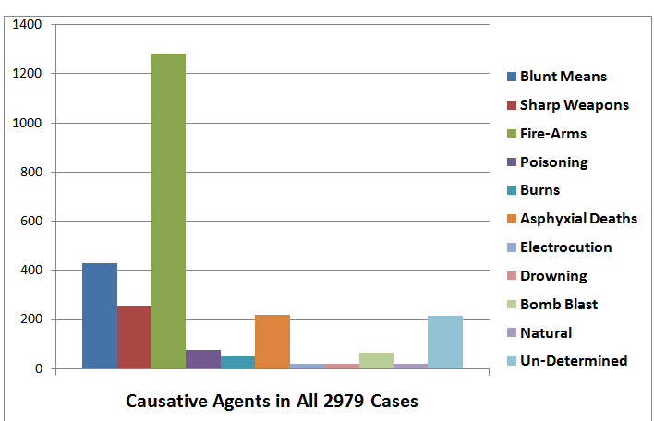
Figure No.1: Causative Agents of 2979 Cases
Types of Neck Compression: Out of 220 selected cases of asphyxial deaths, three types of neck compressions were seen. In these the cases of hanging were 104 (47.27%), strangulations 64 (29.09%) and 52 cases (23.64%) were those of throttling. (Fig: No. 2)
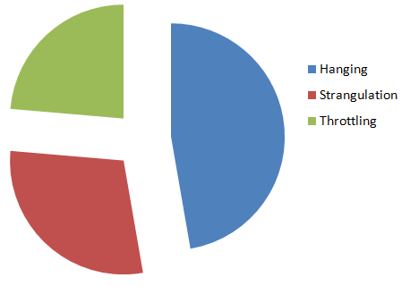
Figure No. 2: Neck Compressions in 220 Deaths
Age & Sex: Commonest decade of ageinvolved was 3rd (035.91%) and next to it was 4th decade (25.91%). 2nd decade was the next (17.27%) (Fig: 3).
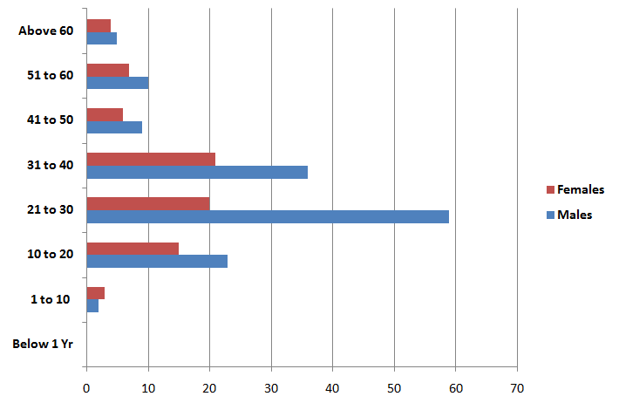
Figure No. 3: Age & Sex Distribution in 220 Asphyxial Deaths
In total 220 cases of asphyxial deaths, 144 were male (65.45%) and 76 cases were those of females (34.55%). (Fig: 4)
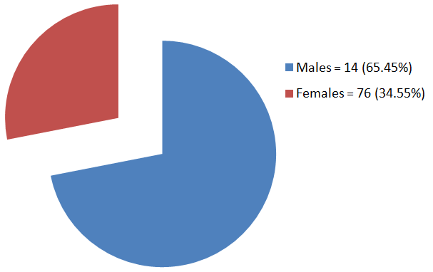
Figure No.4: Sex Distribution in 220 Cases
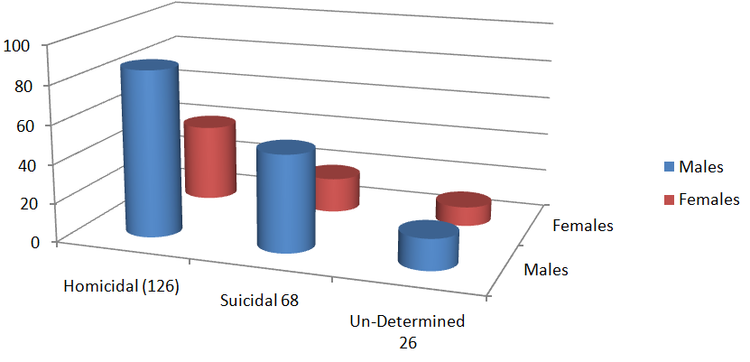
Figure No.5: Manner of Death in 220 Cases
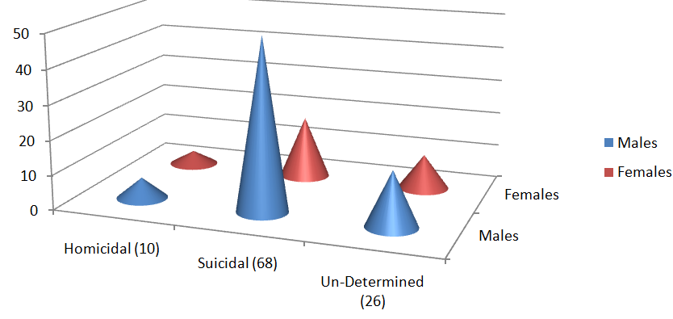
Figure No.6: Manner of Death in 104 Hanging Cases
Regarding age the incidence of hanging was higher in both sexes in the 2nd decade of life in comparison with strangulation and throttling, in which it was higher in the age groups of 21-30 and31-40 respectively. There was none of the case of hanging in first decade.(Table No. 2)
Hanging showed the male to female ratio of 2.25:1.0, 2.05:1.0 was in strangulation and1.26:1.0 was in throttling(Table No. 2).
In reference to gender it was seen that, in hanging males showed had high incidence in 3rd decade of life and in females it was seen in 2nd decade of life. In strangulation males were greater in number in age group of 21-30 yrs. And in females it was seen high in 4th decade. Males manifested number in throttling between age group 21-30 years of life than females who showed it more between 31-40 years of life. Table
No: 2.
Manner of Death: Natural or Un-Natural is the manner of death. The Un-Natural mannersare homicide, suicide and accidental. In our study it also includes the cases in which the cause of death was not ascertainable with certainty due to natural or acquired limitations. Deaths due to accidental asphyxia were not seen in this study.
The homicidal asphyxial deaths were 126 (57.27%), suicidal were 68 in number (30.90%) and in 26 cases (11.82%) the cause of death could not be ascertained. (Fig: 5) In homicidal asphyxial deaths M/F ratio was 02.15:1.0, 02.77:1.0 in suicides and 01.6:1.0 in those, in which the cause of death remained un-Ascertained. Table No: 3
Manner in Hanging: Manner of death in suicides is the most common method adopted in all 104 cases of hanging. Which was seen in 68 cases (68.50%). And they had male/female ratio of 2.78:1. The homicidal hanging was seen in 10 cases(9.62%). The male/female ratio was 1.5:1. In 26 cases (25.0%) of hanging the cause of death could not be ascertained, having male/female ratio of 1.6:1. (Table No. 4) (Fig: No. 6)
The highest incidence in homicidal deaths was seen amongst males in 3rd decade of life, while females showed higher incidence in 2nd decade. In suicidal hanging cases, both the sexes showed higher incidence in 3rd decade.

Table No: 2 Age & Sex Variation
Age  (Yrs) | Total No. of Cases | Ratio of Male/Female in  Hanging(104 cases)  02.25:1.0 |  | Ratio of Male/Female in Ligature Strangulation(64 cases) 02.05:1.0 |  | Ratio of Male/Female in Throttling(52 cases)  01.26:1.0
Age  (Yrs) | Total No. of Cases | M | F | M | F | M | F
<01 | 0.0 | 0.0 | 0.0 | 0.0 | 0.0 | 0.0 | 0.0
01-10 | 5.0 | 0.0 | 0.0 | 1.0 | 2.0 | 1.0 | 1.0
11-20 | 38.0 | 14.0 | 10.0 | 6.0 | 3.0 | 3.0 | 2.0
21-30 | 79.0 | 28.0 | 9.0 | 17.0 | 6.0 | 14.0 | 5.0
31-40 | 57.0 | 19.0 | 4.0 | 12.0 | 7.0 | 5.0 | 10.0
41-50 | 15.0 | 4.0 | 4.0 | 2.0 | 1.0 | 3.0 | 1.0
51-60 | 17.0 | 5.0 | 4.0 | 3.0 | 1.0 | 2.0 | 2.0
>60 | 9.0 | 2.0 | 1.0 | 2.0 | 1.0 | 1.0 | 2.0
Total No. | 220.0 | 72.0 | 32.0 | 43.0 | 21.0 | 29.0 | 23.0

Table:3 Manner in 220 Asphyxial Deaths
Years  of Age | Number  of  Cases | M/F ratio in Homicidal  Cases02.15:1.0 |  |  | M/F ratio in Suicidal  Cases02.77:1.0 |  |  | M/F ratio in Un-determined  Cases01.6:1.0
Years  of Age | Number  of  Cases | Male | Female | Total | Male | Female | Total | Male | Female | Total
<01 | 0 | 0 | 0 | 0 | 0 | 0 | 0 | 0 | 0 | 0
01-10 | 5.0 | 2.0 | 3.0 | 5.0 | 0.0 | 0.0 | 0.0 | 0.0 | 0.0 | 0.0
11-20 | 38.0 | 8.0 | 6.0 | 14.0 | 5.0 | 9.0 | 14.0 | 7.0 | 3.0 | 10.0
21-30 | 79.0 | 36.0 | 11.0 | 47.0 | 20.0 | 06.0 | 26.0 | 4.0 | 2.0 | 6.0
31-40 | 57.0 | 20.0 | 14.0 | 34.0 | 16.0 | 02.0 | 18.0 | 3.0 | 2.0 | 5.0
41-50 | 15.0 | 8.0 | 2.0 | 10.0 | 4.0 | 01.0 | 5.0 | 0.0 | 0.0 | 0.0
51-60 | 17.0 | 6.0 | 3.0 | 9.0 | 5.0 | 0.0 | 5.0 | 0.0 | 3.0 | 3.0
>60 | 9.0 | 6.0 | 01.0 | 7.0 | 0.0 | 0.0 | 0.0 | 2.0 | 0.0 | 2.0
Total No.  of Cases | 220.0 | 86.0 | 40.0 | 126.0  57.27% | 50. | 18.0 | 68.0  30.91% | 16.0 | 10.0 | 26.0  11.82%
Table 4: In 104 Hanging Cases (Manner of Death)
Years of  Age | Total  Cases | In 10 Homicidal  Cases 9.62%  M/FRatio 01.5:1.0 |  | In 68 Suicidal  Cases 65.38%  M/FRatio 02.78:1.0 |  | In 26 Un-Determined  Cases 25.0%  M/FRatio 01.6:1.0
Years of  Age | Total  Cases | M | F | M | F | M | F
<1 Years | - | - | - | - | - | - | -
1-10 Years | - | - | - | - | - | - | -
11-20 Years | 024 | 02 | 01 | 05 | 06 | 07 | 03
21-30 Years | 037 | 04 | 02 | 02 | 05 | 04 | 02
31-40 Years | 023 | - | - | 016 | 02 | 03 | 02
41-50 Years | 08 | - | - | 05 | 01 | - | 03
51-60 Years | 09 | - | - | 05 | 01 | - | 03
>60 Years | 03 | - | 01 | - | - | 02 | 0
Total No. of Cases | 0104 | 06 | 04 | 050 | 018 | 016 | 010

DISCUSSION
Incidence of Asphyxial Death: This study shows that, there were 220mechanical asphyxial deaths in all 2979 post-mortems conducted. The incidence of asphyxial deaths is 7.39%. This is high than what was reported by Rehman et al. (1.6%)⁷, Malik SA (1.75%)⁸, and Bashir MZ (1.88%)⁹ in deaths due to asphyxia. And of all types of deaths it was Srivastava AK (2.94%)¹⁰ and of total asphyxial deaths it was 24.53%, Hussain SM (5%)¹¹ of total deaths & of asphyxial deaths it was 82%, and 1.17% in Verma SK¹²& 12.4% in Vermici S¹³ of & 5.5% of all types of deaths, it is lower than 15.7% in Azmak D¹⁴.
Types of Neck Occulusion: Hanging has the highest number, having 104 cases (47.27%), the ligature strangulation cases are 64(20.09%) and 52 cases of throttling are seen (23.64%).This incidence is comparable with 80.70% of hanging/ligature strangulation & throttling 19.30% Rehman IU⁷, 61.17% in hanging, 21.19% in strangulation &in throttling 17.64% in Malik Sa⁸, 57.0% hanging, 21.0% strangulation, and 18.0% throttling in Bashir MZ⁹, 19.23% ligature strangulation, 46.15% throttling in Srivastava¹⁰, 69.0% hanging Hussain SM¹¹ ,12.40% ligature strangulation Demirci M¹³, 41.80% hanging, 2.90% strangulation & 2.30% throttling Azmak D¹⁴, 85.0% hanging & strangulation and 6.0% throttling Sharma BR¹⁵.
Age and Sex Distribution: In all asphyxial deaths the highest incidence seen is in ages between 3rd decades of life. This age can be compared with that of 57.0% of Hussain SM¹¹, 3rd decade of life in Verma SK¹². On the other hand in the study of Azmak¹⁴ et.al; 41.90 years was the average age seen. Bowen¹⁶ has shown greater number of hanging in 5th decades of life. Guarner & Hanzlick¹⁷ in USA mentioned 3rd decades of life the greatest number.
Male/Female Ratio: The hanging is showing 2.25:1 male/female ratio in our study, strangulation of 2.05:1 and in throttling it is 01.26:1.0. The males are showing highest number in all types ofmechanical asphyxial deaths.
Males are higher in number 69.23%, than females showing 30.76%. This trend is comparable with others studies of Azmak¹⁴83.9% males, and of Bashir MZ⁹ et al; showing 02.7:1.0 Males (73.07%)& Females (26.92%).
The study of Bashir MZ et.al; ⁹ has shown males as 58.9% and females 41.02%in strangulation and throttling. For strangulation study of Azmak D¹⁴ has shown 1.0:3.0 male/female ratio& 1.0:2.0 inmanual throttling, and in contrast to it study of Srivastava AK¹⁰ narrated males(30.77%) & females(69.23%).
Manner of Death: The incidence of suicide in hanging in this study is (65.38%), which is less than that of Bashir MZ⁹(86.53%). Homicide is (09.62%) which is greater than (03.84%) of Bashir MZ⁹, but is less than that of Bowen DA¹⁶(95%).
No case of accidental hanging was reported in our study; while Bowen DA¹⁶ study showed 5% deaths because of accidental auto-erotic asphyxia.
CONCLUSION
Mechanical asphyxial deaththe commonest causes of deaths amongstall un-natural deaths in this region. And for that hanging is the most preferable method used suicide in mechanical asphyxias. Suicidal hanging is seen in all age groups but mostly is seen in young ages especially 21-30 years, and regarding gender male has shown higher incidence as compared to females for the reason of socio-economic liabilities mainly on them.
Conflict of Interest: The study has no conflict of interest to declare by any author.
REFERENCES
- Vanezuis R. The Pathology of Neck. 1st ed. Butterworth & Co. London; 1989.p.56-75.
- Knight B. Forensic Pathology. 2nd ed. Amold: London; 1996.p.90.
- Shepherd R. Simpson Forensic Medicine. 12th ed. Arnold: London;2003.p.97.
- Gordon I, Shapiro HA. editors. Forensic Medicine. A guide to Principles. 2nd ed. Churchill Livingstone: London;1984p.p102-118.
- Parikh KC. Parikh’s Text Book of Medical Jurisprudence, Forensic Medicine and Toxicology. 7th ed. CBS Publishers India; 2006.p.3,34-3, 57.
- Awan RN. Principles and Practice of Forensic Medicine. 1st ed. M. Ishtiaq Printers;2009.p.
106-12.
- Rehman IU, Aziz KK, Kaheri GQ, Bashir Z. The Fracture of Hyoid Bone in Strangulation. A review Annals 2000;6(4):396-98.
- Malik SA, Aziz K, Malik AR, Rana PA. Fracture of Hyoid Bone: An indicator of death in strangulation. Pak Postgraduate J 1999;10(4):
112-115.
- Bashir MZ, Malik AR, Malik SA, Rana PA, Aziz K, Chaudhry MK. Pattern of Fatal Compression of the Neck. A five Year study in Lahore. Annals 2000; 6(4):396-98.
- Srivastava AK, Gupta SMD, Tripathi CB. A study of Fatal Strangulation Cases in Varanasi (India). Am J Forensic Med Pathol 1987;8(3):220-24.
- Hussain SM, Mughal MI, Din SZ, Baluch NA, Bukhari SMZ, Malik S, et al. An autopsy study of Asphyxial Deaths. Med Forum 2008;19(4):27-30.
- Verma SK, Lal S. Strangulation deaths during 1993-2002 in East Delhi (India). Leg Med Tokyo 2006;8(4):1-4.
- Demirci S, Dogan KH, Erkol Z, Gunaydin G. Ligature Strangulation Deaths in The Province of Konya (Turkey). J Forensic Leg Med 2009; 16(5): 248-52.
- Azmak D. Asphyxial Deaths. A Retrospective Study and Review of the Literature. Am J Forensic Med Pathol 2006;27(2): 134-144.
- Sharma BR, Harish D, Sharma A, Sharma S, Singh H. Injuries to The Neck Structures in Death due to Constriction of Neck, with a special reference to Hanging. J Forensic Leg Med 2008;15(5):298-305.
- Bawon DA. Hanging-A review. Forensic Sci Int 1982; 20:247-49.
- Demirci S, Hanzlick R. Suicide by Hanging. Am J Forensic Med Pathol 1987;8(1): 23-26.

