Original Article

Aluminium Phosphide (Wheat Pill) Poisoning Cases
An Analysis of Aluminium Phosphide (Wheat Pill) Poisoning Cases in Bahawalpur
Ahmed Raza Khurram¹, Talha Naeem Cheema², Aslam Baig³, Ayesha Muzzammil³, Aftab Ali⁴ and Abdul Ghani²
ABSTRACT
Objective: To analyze demographic profiles, frequency, morbidity and mortality of Aluminium Phosphide (wheat pill) poisoning cases reported at accident and emergency department of Bahawal Victoria Hospital Bahawalpur between the years 2019 to 2021.
Study Design: Retrospective Study
Place and Duration of Study: This study was conducted at the A&E Department B.V Hospital Bahawalpur, over a period of three years from 1st January 2019 to 31st December 2021.
Materials and Methods: Data of a total of 104 cases was analysed with regard to age and gender distribution, morbidity and mortality.
Results: Out of 104 cases, most common age group was 20-40 years and commonly, the female predominance of 72% is noted among all cases. The mortality rate calculated as 54.8%.
Conclusion: Aluminium Phosphide is a readily available lethal poison and with no specific antidote. Aluminium Phosphide poisoning is associated with high mortality and suicide predominantly among females and in younger age groups.. Multiple approaches are required to reduce mortality and morbidity associated with intentional poisoning.
Key Words: Aluminium Phosphide, Wheat pill, Bahawalpur, Punjab
Citation of article: Khurram ARM Cheema TN, Baig A, Muzzammil A, Ali A, Ghani A. An Analysis of Aluminium Phosphide (Wheat Pill) Poisoning Cases in Bahawalpur. Med Forum 2022;33(11):27-31.

INTRODUCTION
Wheat pill or Aluminium phosphide poisoning is common in the sub-continent especially in many countries of South Asia that primarily thrive on agriculture. It is used as an insecticide and rodenticide to prevent the wheat and rice crop infestation. It is widely available and used in several developing countries like Pakistan, India, Iran, Morocco and Nepal.¹
Wheat pill or rice pill is a commonly available pesticide that consists of 65% Aluminium or Zinc phosphide and the remaining constituents are inert to prevent decomposition of the pill.

^{1.} Department of Forensic Medicine, DG Khan Medical College, DG Khan.
^{2.} Department of Forensic Medicine, QAMC, Bahawalpur.
^{3.} Department of Forensic Medicine, CMH Institute of Medical Sciences, Bahawalpur.
^{4.} Department of Forensic Medicine, Bakhtawar Amin Medical College, Multan.

Correspondence: Aslam Baig, Associate Professor of Forensic Medicine, CMH Institute of Medical Sciences, Bahawalpur.
Contact No: 03006809301
Email: aslam 1 baig1@ gmail.com

Received: June, 2022
Accepted: August, 2022
Printed: November, 2022

Available in the form of pellets, sachets, or powder, it is a highly potent insecticide, as it is effective against all stages of insect life and leaves very small amounts of non-toxic residue on food crops.² Globally about 2 million people are affected due to suicidal attempts with self-poisoning according to WHO estimates, while incidence of accidental poisoning amount to 1 million.³ In European countries the sale of Aluminum Phosphide pills is restricted to qualified users therefore for the developed world, most of the cases are due to accidental exposure to fumigants such as improper storage and disposal, re-entry in the fumigant structures and drift from the agricultural fields.⁴ Contrary to this in South Asia, suicidal attempts due to poisons are calculated as 35.3% which is second only to hanging (55.8%).⁵ According to Mehrpour et al. the Aluminum Phosphide poisoning accounts for 25 % of all suicide attempts in India and 31% of the fatal suicide attempts in Iran.⁶ In a large study done in India, the mortality was reported as 60%.⁷The incidence is high in developing countries because of easy market access, lack of regulation, poor surveillance or information systems, absence of proper training and awareness and inadequate protective gear.⁸ Pakistan is no exception and the incidence of Aluminum Phosphide poisoning is on the rise in Pakistan as well since it is a cheap and readily available poison.⁹
This study aimed at evaluating the trends of acute AlP poisoning, number of cases, either suicidal or accidental, general outcome of poisoning and related parameters like demographic profile, patient mortality and morbidity by a comprehensive retrospective analysis of patient records over a span of three years in the Bahawal Victoria Hospital, Bahawalpur. The current research also posed a question of whether AlP poisoning is a true public health problem that urges the reinforcement of proper preventive and control measures to limit its rising morbidity and mortality.
MATERIALS AND METHODS
This work is a retrospectively cross-sectional study performed at accident and emergency department Bahawal Victoria Hospital Bahawalpur. A total number of 104 cases that presented with the history of wheat pill ingestion were analyzed covering a period of three years from1st January 2019 to 31st December 2021.
Study population (patients): All cases of Aluminium Phosphide poisoning that were brought to accident and emergency department of Bahawal Victoria Hospital Bahawalpur from January 2019 to December 2021.
I.Inclusion criteria: All patients with a sure history of absolute exposure to AlP only without any other toxic exposures, of all ages, both sexes, and from all areas served by the hospital in the study.
II.Exclusion criteria: Patients with uncertain history of exposure, those with a history of co-ingestion of other poisons, drugs, or insecticides, and those with unknown poisoning outcomes e.g. those who left the hospital against medical advice. All those cases that were brought to accident and emergency department after death, were excluded from the study
Methods:
I.Tools of the study and technical design: We examined all patient records of accident and emergency department Bahawal Victoria Hospital, Bahawalpur during the last three years and, using a checklist, we extracted data about patients of Aluminium phosphide poisoning including their age, gender, residence, occupation, mode of exposure, the lag time between exposure and hospital presentation. Frequency and percentage was calculated for age group and gender.
All patients were divided according to their poisoning outcome into recovered and dead (non-recovered). All the above-mentioned data were statistically evaluated among each year and compared in both recovered and dead patients to detect their impact on patient outcomes.
II.Administrative and Ethical design: The design of the study was approved by the Ethical Committee of the Quaid-e-Azam Medical University with the letter number IRB:#.. All patient data were kept confidential and used only for research purpose.
The collected data was analysed on SPSS v 22.0.
RESULTS
Data of 104 cases was recorded starting from 1st January 2019 to 31st December 2021. Table-1 and Fig.1 reflect that most common age group is 20-40 years n=52 (50.0%), while >40 years of age have shown the least number of cases n=5(4.8%). Table-1 shows the maximum number of Aluminium phosphide poisoning cases was registered in 2020, n= 48 with a female predominance of 72.9%, while minimum number of cases was noted in 2019 n=26.

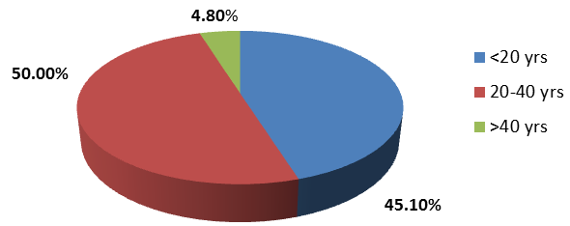
Figure No.1: Percentage distribution of cases from 2019-2021
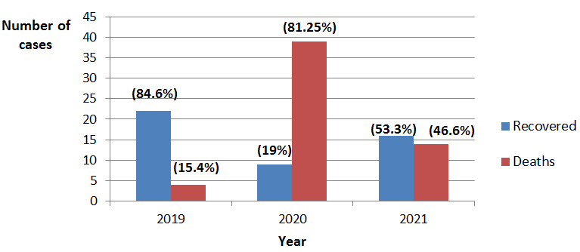
Figure No.2: Outcome of Aluminium phosphide poisoning cases fron the year 2019 to 2021

Table No. 1: Age groups with gender distribution
Age(Years) | 2019 |  | 2020 |  | 2021 |  | Total
Gender | Male | Female | Male | Female | Male | Female
< 20 | 2 | 4 | 7 | 18 | 7 | 9 | 47 45.1%
20-40 | 7 | 9 | 6 | 17 | 4 | 9 | 52 50.0%
>40 | 2 | 2 | 0 | 0 | 1 | 0 | 5 4.8%
Total | 11 | 15 | 13 | 35 | 12 | 18 | 104
Total | 26 |  | 48 |  | 30 |  | 104
Percentage | 42.3% | 57.7% | 27.0% | 72.9% | 40.0% | 60.0% | Mean28.4 ± 7.32

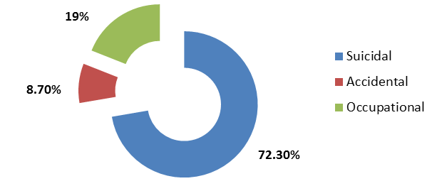
Figure No.3:.Percentage of cases according to mode of poisoning
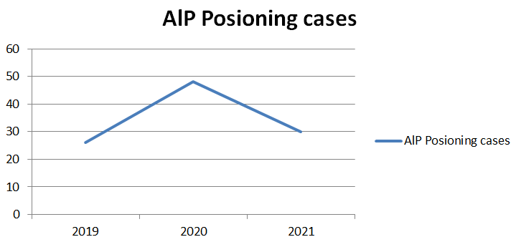
Figure No.4: Frequency of cases from 2019-2021
Figure.2 portrays, the maximum number of deaths from aluminium phosphide poisoning was registered in 2020 i.e. 39(81.25%), and the number of recovered patients was 9. The year 2019 saw the least number of deaths i.e 4(15.4%) and highest number of recovered patients i.e 22(84.6%). All these 22 presented early for treatment or were immediately attended. Figure. 3 shows that a large proportion of cases was suicidal, 72.3% and the remaining were accidental or occupational whereas figure.4 highlights the frequency of Aluminium phosphide cases from 2019 to 2021.
DISCUSSION
The world has seen a phenomenal hike in death toll due to suicide over the past decade. According to WHO estimate, around 20% of global suicides are due to pesticide self-poisoning, most of which occur in rural agricultural areas in low and middle-income countries. A similar trend has followed at home in Pakistan. In a recent study, Safdar et al reported that that pesticides (organophosphates and aluminium phosphide) are the most frequently used agents for suicide across Pakistan.¹⁰
Pakistan’s economy thrives profoundly on the country’s agriculture. The need to meet the ever-increasing demand is one of the major driving forces of the extraordinary rise in pesticide use in farming and agriculture, thus making them readily available for consumers. The increasing number of poisoning cases can also be attributed to the marketing of modern agrochemicals while their toxic effects are not known to the users.¹¹ Several studies have investigated minimal or a complete lack of knowledge and awareness of pesticide hazards in these regions.^{12,13,14}
Our study found that females were the most predominantly affected group in all three years with a female to male (F:M) ratio of 60:40 in the year 2021 (Table.1). Moreover approximately same ratios were observed in 2020 and 2019. This can be attributed to limited involvement of women in decision making about pesticide use and work in the fields or at home where pesticides are stored. Women could be at the receiving end of negative cultural influences. This along with added stress of raising a family, managing domestic finances compounded by the Covid-19 pandemic and its impact may have contributed to unprecedented behavioral and psychological changes inducing extreme life-threatening thoughts. A cluster of factors like illiteracy, low self-esteem, emotionally unstable behavior and easy availability of such poisons thus contributes to increased frequency of poisoning among females. A similar pattern of gender distribution with female preponderance was reported by Qureshi
et al in 2018 and several other studies in Pakistan.^{3,15,16} The findings of local studies were also consistent with studies conducted in North India, Bangladesh, and Egypt where female predominance was reported in studies based on Aluminium phosphide poisoning.^{7,17,18,}
The mean age of patients in our study was 28.4 ± 7.32, while most commonly involved age group for Aluminium phosphide poisoning in this study was 20- 40 years, for both males and females (Table-1). This can be attributed to the fact that people in this age group face maximum hardships of life leading to psychological struggles and suicidal tendencies. These results are comparable with a study conducted at Dhakka, Bangladesh (2015), where Saha et al noted that the maximum number of cases ranged between 15 to 45 years of age.¹⁷ A similar age range, that is 18 to 45 years was also predominant in recent Egyptian studies.^{18,19}
In this study the highest mortality rate was registered in 2020 with 39 (81%) deaths and just 9 recoveries (19%) from a total of 48 patients that year (Fig.2). A high mortality rate in 2020 can be attributed to late presentation and hence delayed resuscitation and emergency medical care. During the lockdown due to the covid-19 pandemic, there was widespread panic, anxiety and fear associated with visiting hospitals which may have resulted in late presentation of cases. Elikana et al reported in 2020 that patients who reached hospital early within a few hours had better chances of survival as compared to those who suffered any delays to medical treatment after ingestion.²⁰ Early resuscitation with lavage and drugs improved prognosis. The same was true for our study where the least mortality rate (15.4%) was observed in the year 2019, where all 22 patients who survived out of a total of 26, presented in time and were attended early.
Alarmingly, this study highlights that 72.3% cases of Aluminium phosphide poisoning were suicide attempts and a little over 27 percent were accidental or occupational. Social determinants such as financial problems, gender and cultural stressors influence suicide. Safdar et al identified economic issues, family conflicts, illicit spousal relationships, serious illness and failed romances as commonly identified reasons for suicide. ¹¹ Pakistan is an economically strained country with a high unemployment rate. Previous studies similarly found a range of socially and culturally specific domestic family conflicts, typically involving spouses, in-laws, parent–child conflicts, unfulfilled expectations at work or failure in school, mental turmoil from violence, financial loss, anxiety depression, and other pre-existing mental health conditions to be causative factors in suicide attempts.²¹Pathirathna et al reported in the year of 2021 that unexpected behavioral changes during the Covid-19 pandemic may have contributed to the rising trend of suicidal attempts reported.²⁰
A drop in the number of cases of Aluminium phosphide poisoning was seen in the year 2021.One plausible explanation to this finding can be resumption of normal life following the pandemic lockdown; strict monitoring of over the counter sales of wheat pill by the retailers and lastly, a decline in use of pesticide induced self-poisoning for attaining suicide by the patients. However more research is needed to confirm this. Similar changing trends were noted by Arafat et al, observing that hanging is more common method of suicide with a growing penchant towards firearm inflicted suicidal attempts.²¹
CONCLUSION
Aluminium Phosphide (ALP) is termed as ‘agent of sure death’ since it is a cheap and readily available lethal poison with no specific antidote and the treatment is only supportive. Aluminium Phosphide poisoning is associated with very high mortality and suicide rates especially in younger age groups (20-40 yrs) and in females. Multiple approaches are required to reduce mortality and morbidity associated with intentional poisoning. Interdiction or enforcing strict regulations on open sales of Aluminium Phosphide or wheat pills would be one approach. Search for safer alternatives and raising the population’s awareness about appropriate handling or storage through community education programs or campaigns could help curb this problem. Moreover, awareness on early intensive care with availability of sub-specialties or an independent poisoning control center separate from accident and emergency department of hospitals, can help reduce mortality rate. On the patient assessment scale, further extensive and comprehensive clinical studies aiming to design a reliable prognostic system through more specific and sensitive parameters could improve morbidity and mortality rates.
Author’s Contribution:
Concept & Design of Study: | Ahmed Raza Khurram
Drafting: | Talha Naeem Cheema, Ayesha Muzzammil
Data Analysis: | Aftab Ali, Abdul Ghani
Revisiting Critically: | Aslam Baig, Ahmed Raza Khurram
Final Approval of version: | Aslam Baig, Ahmed Raza Khurram
Conflict of Interest: The study has no conflict of interest to declare by any author.
REFERENCES
- Ghazi MA. Wheat pill (aluminum phosphide) poisoning; Commonly ignored dilemma. A comprehensive clinical review. Professional Med J 2013;20(6):855-863.
- Moghadamnia AA. An update on toxicology of aluminum phosphide. DARU. J Pharm Sci 2012;20(1):25-32.
- Sadia S, Qasim AP, Siddiqui BA, Qasim JA. Human poisoning. Prevalence of human poisoning in Sargodha, Pakistan. Profess Med J 2018;25(02): 316-20
- Burgess JL, et al. Fumigant-related illnesses: Washington State’s five-year experience. J Toxicol Clin Toxicol 2000;38(1):7-14.
- Arafat SY, Ali SA, Menon V, Hussain F, Ansari DS, Baminiwatta A, et al. Suicide methods in South Asia over two decades (2001–2020). Int J Social Psychiatr 2021;67(7):920-34.
- Mehrpour O, Jafarzadeh M, Abdollahi M, A systematic-review of aluminium phosphide poisoning. Arh Hig Rada Toksikol 2012;63(1):
61- 73.
- Siwach SB, Gupta A, The profile of acute poisonings in Harayana-Rohtak Study. J Assoc Physicians Ind 1995;43(11):756-9.
- Thundiyil JG, Stober J, Besbelli N. Pronczuk J. Acute pesticide poisoning: a proposed classification tool. Bull. World Health Organ 2008;86(3):205-209.
- Khan ZU. Rise in wheat pill poisoning: study. Dawn 1/20 / 2013 ] ; Available from : http://arcliives.dawn.com/archives/70423.
- Safdar M, Afzal KI, Smith Z, Ali F, Zarif P, Baig ZF. Suicide by poisoning in Pakistan: review of regional trends, toxicity and management of commonly used agents in the past three decades. BJ Psych Open 2021;7(4):e114.
- Sandhu SS, Dalal JS. Trends of Poisoning in Faridkot region of Punjab-A retrospective study of one year. J Indian Acad Forensic Med 2010;32:
8-10.
- Ahmad A, Shahid M, Khalid S, Zaffar H, Naqvi T, Pervez A, et al. Residues of endosulfan in cotton growing area of Vehari, Pakistan: an assessment of knowledge and awareness of pesticide use and health risks. Environ Sci Pollut Res Int 2019; 26(20): 20079–91.
- Saeed MF, Shaheen M, Ahmad I, Zakir A, Nadeem M, Chishti AA, et al. Pesticide exposure in the local community of Vehari District in Pakistan: an assessment of knowledge and residues in human blood. Sci Total Environ 2017; 587–8:137–44.
- Khan M, Mahmood HZ, Damalas CA. Pesticide use and risk perceptions among farmers in the cotton belt of Punjab, Pakistan. Crop Protection 2015;67:184–90.
- Qureshi M, Nadeem S, Ahmad T, Tariq F, Rehman H, Qasim A. Aluminium Phosphide Poisoning: Clinical Profile and Outcome of Patients Admitted in a Tertiary Care Hospital. Annals of Punjab Medical College (APMC) 2018;12(3):191-194.
- Global Greengrants Funds. Poisoned by Pesticides in Pakistan. Global Greengrants Funds, 2011 (https://www.greengrants.org/2011/11/10/poisonedby-pesticid.
- Saha JK, Azad KAK, Hossain MZ, Amin MR, Ahmed M, Ahsan HMN, et al. Aluminium phosphide poisoning cases in a tertiary care hospital. J Dhaka Med Coll 2015;23(1):3–6.
- Deraz R, Elrafey D, Mesallam D. Acute Aluminium Phosphide Poisoning in East Delta, Egypt: a Growing Public Health Problem Over the Last Five Years. Egypt Society Clin Toxicol J 2022;10(1):49-61.
- Lekei E, et al. Acute pesticide poisoning amongst adolescent girls and women in northern Tanzania. BMC Public Health 2020;20(1):1–8.
- Pathirathna ML, Nandasena HMRKG, Atapattu AMMP, et al. Impact of the COVID-19 pandemic on suicidal attempts and death rates: a systematic review. BMC Psychiatr 2022;22:506.
- Arafat SY, Ali SA, Menon V, Hussain F, Ansari DS, Baminiwatta A, et al. Suicide methods in South Asia over two decades (2001–2020). Int J Social Psychiatr 2021;67(7):920-34.

